Facets/descriptors at Library level: search & error message
e-SMP-3614 | Bug | WIP
I try to display the facet 03 only so in the search part I type “03” on facet field then this error message is displayed.
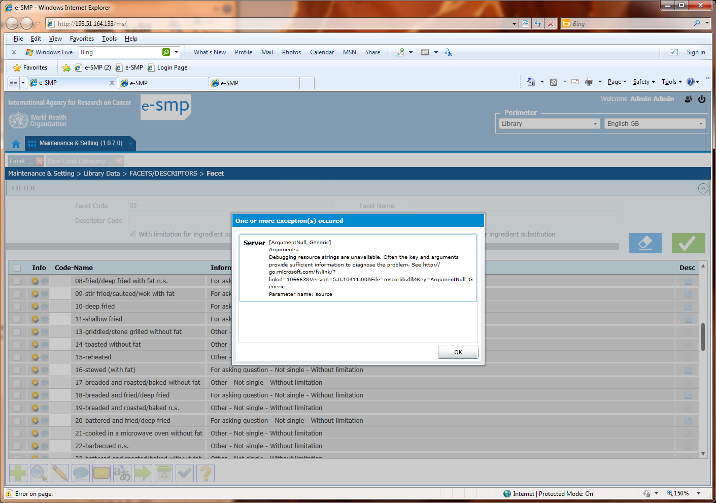

Facets/descriptors at Library level: delete descriptor 00
e-SMP-3615 | Bug | Closed
I select the facet 00 and the attached descriptor 00 and I click on the delete button. The following message is displayed. I can delete a facet but not the attached descriptor??? How is it possible??
When I come back to the list, both records are not displayed/no more available.
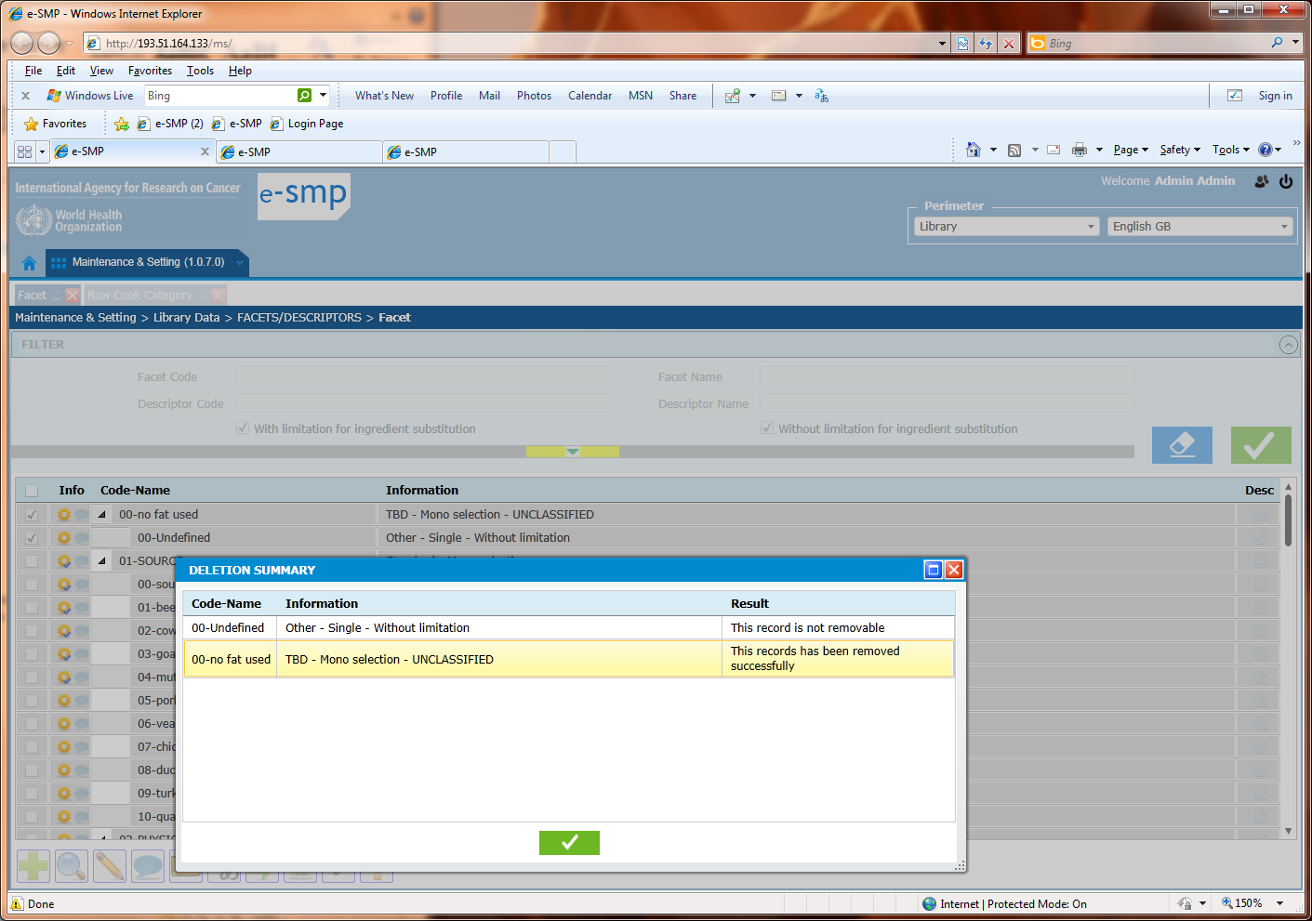

Facets/descriptors at Project level: blue cross
e-SMP-3616 | Bug | Closed
At library level the facet 15 descriptors 00 is validated
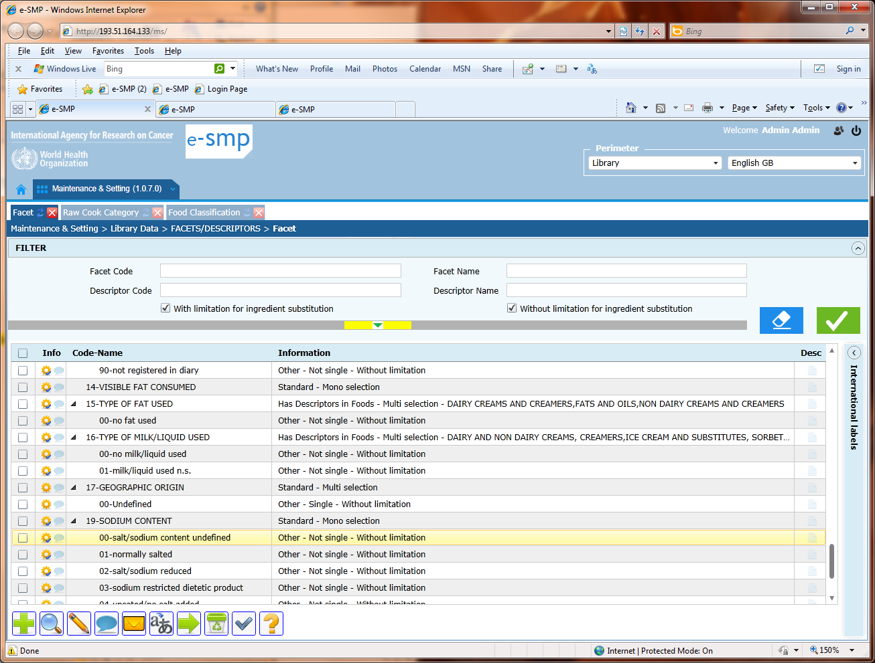
At Project level, when I select the blue cross button, the facet 15 is proposed but not the attached descriptor coded 00?
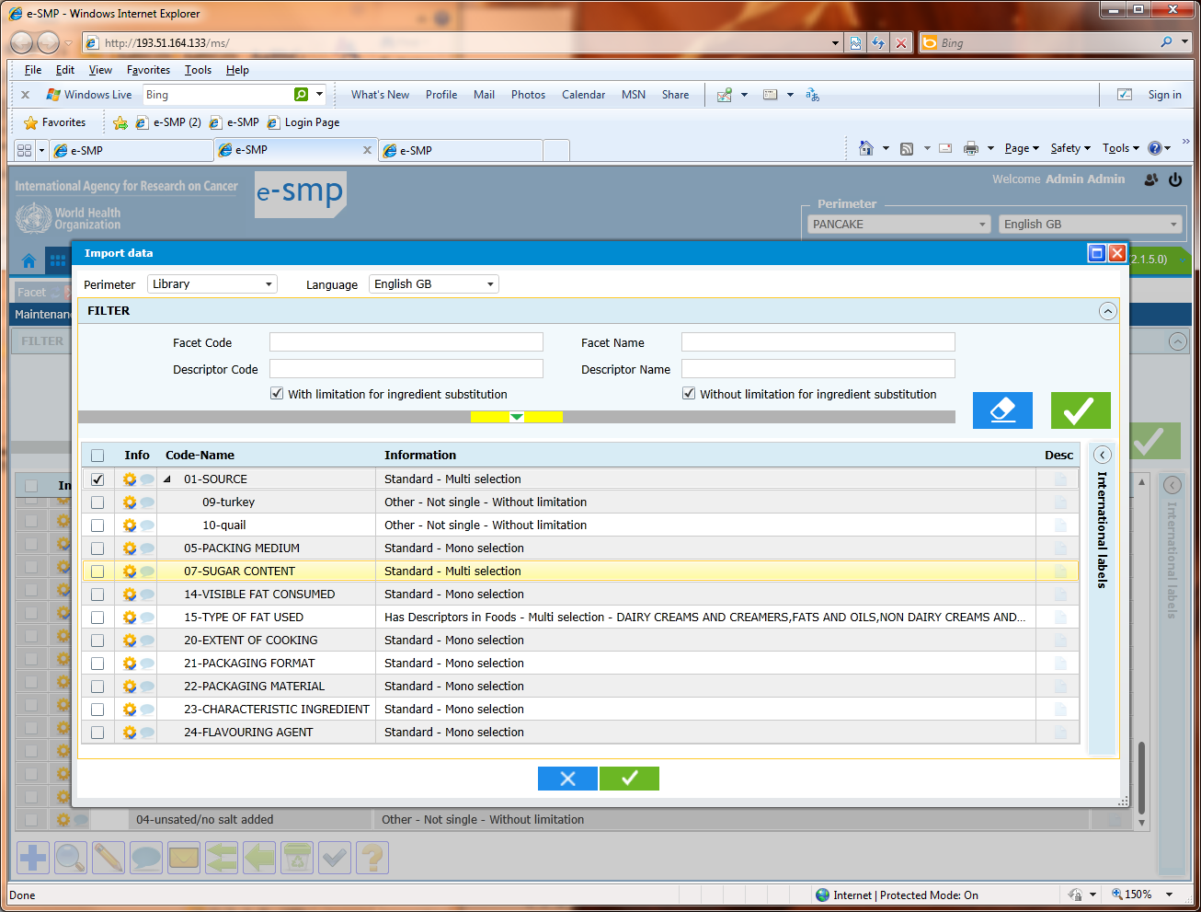
This descriptor is not been already selected, see below
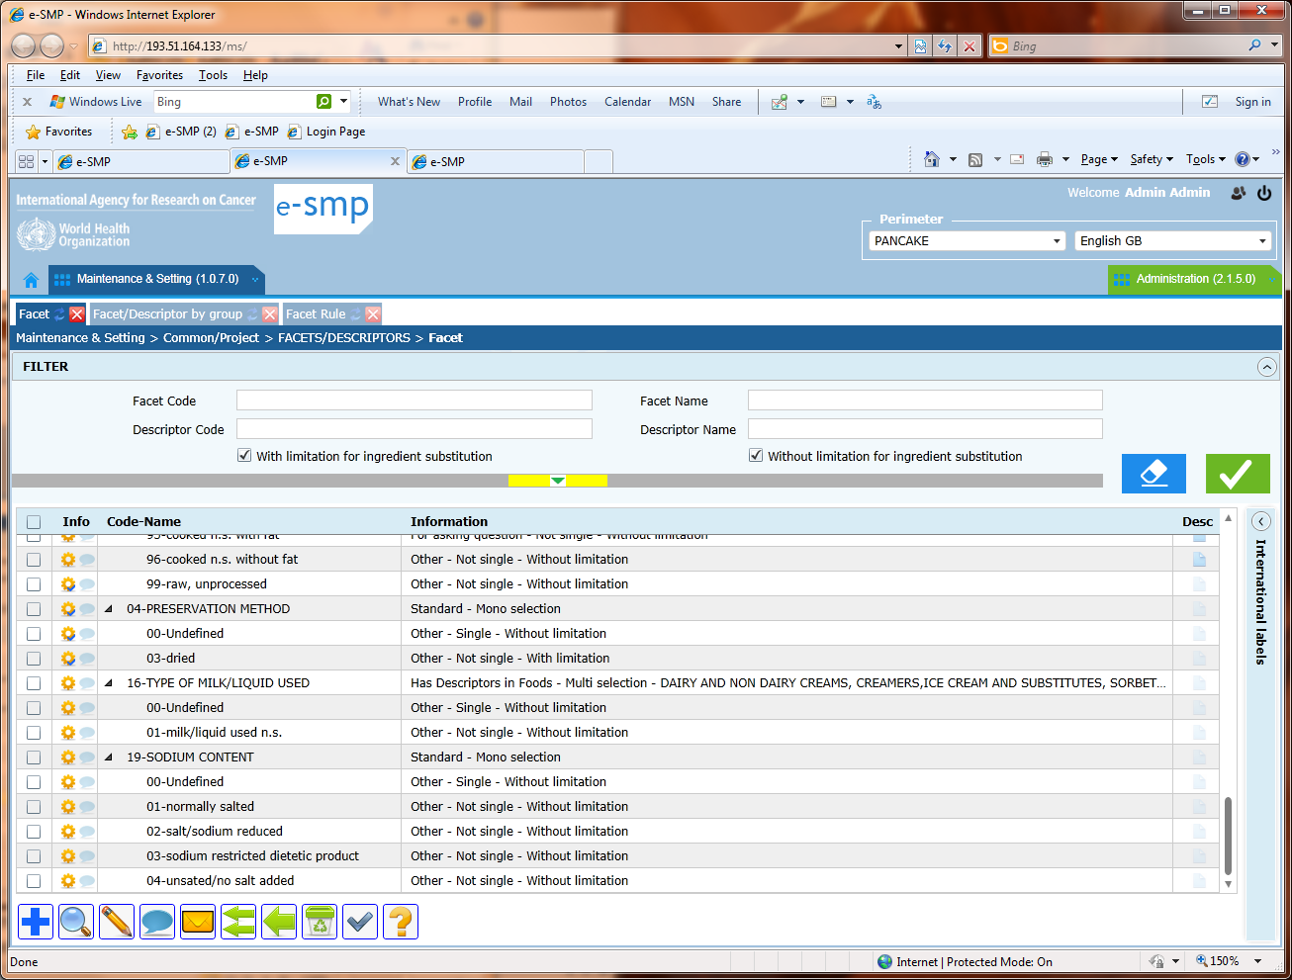

Facets/descriptors at Project level: blue cross and descriptor coded 00
e-SMP-3617 | Bug | Closed
At project level, we cannot create new descriptor even automatically. The blue cross allows to select from the Library and that all.
When I select a facet (e.g. facet 15) that not have descriptor attached, the descriptor coded 00 is automatically create with label undefined that it is not relevant. The blue cross allows to select in the library the possible facets/descriptors not to generate new descriptors.
In the following example, the descriptor 00 of facet 15, already exists in the library and label is “no fat used” no “undefined”.
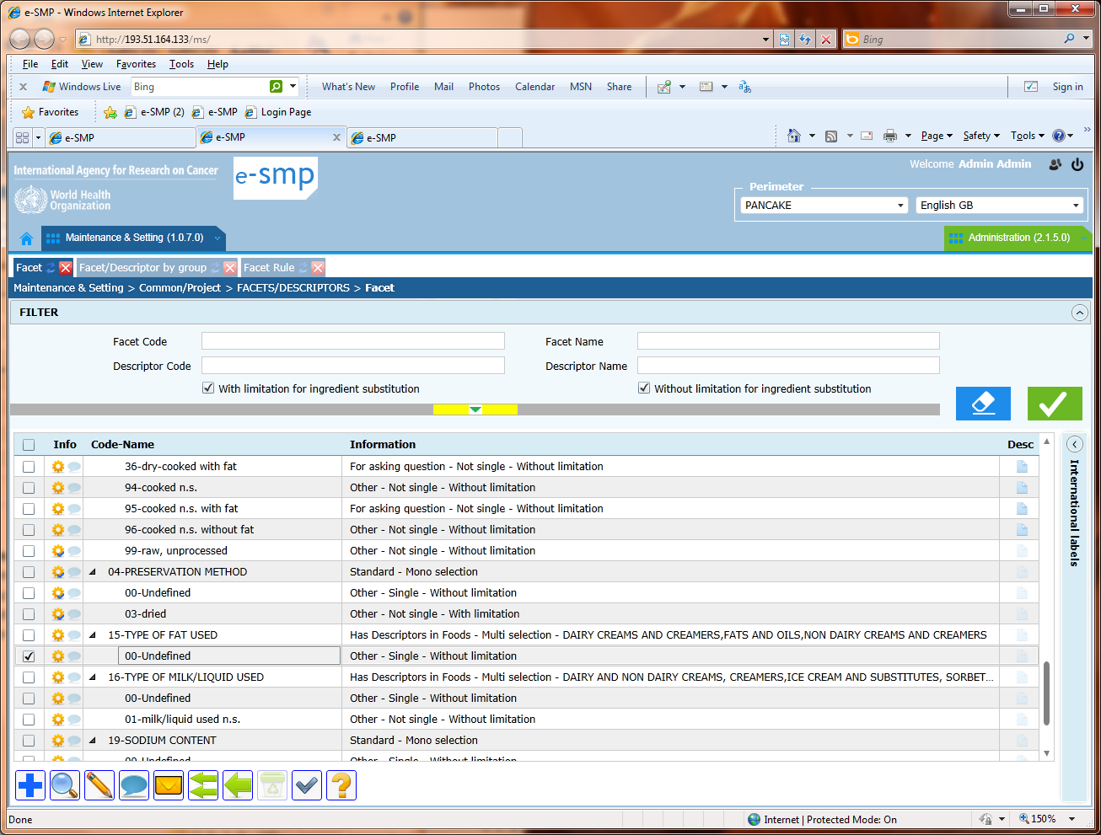

Facets/descriptors at project level: Fiche with updatable fields.
e-SMP-3618 | Bug | Reviewed
Please can you review the fiche at project level? We cannot update a facet or a descriptor at project level (nothing).
Today, I can open a facet fiche and update some fields as order, group, label… but for some facets I cannot???? For example, I can modify the facet coded 02 but not the facet 19???
Why do we have this difference? How information is stored in the facets/descriptors tables?

Please can you review this screen with all the attached functions, please?

Fade by group at project level: Default field
e-SMP-3619 | Bug | Closed
The rule ‘Only 1 default per group/subgroup and facet’ is not followed.
See following pop-up:
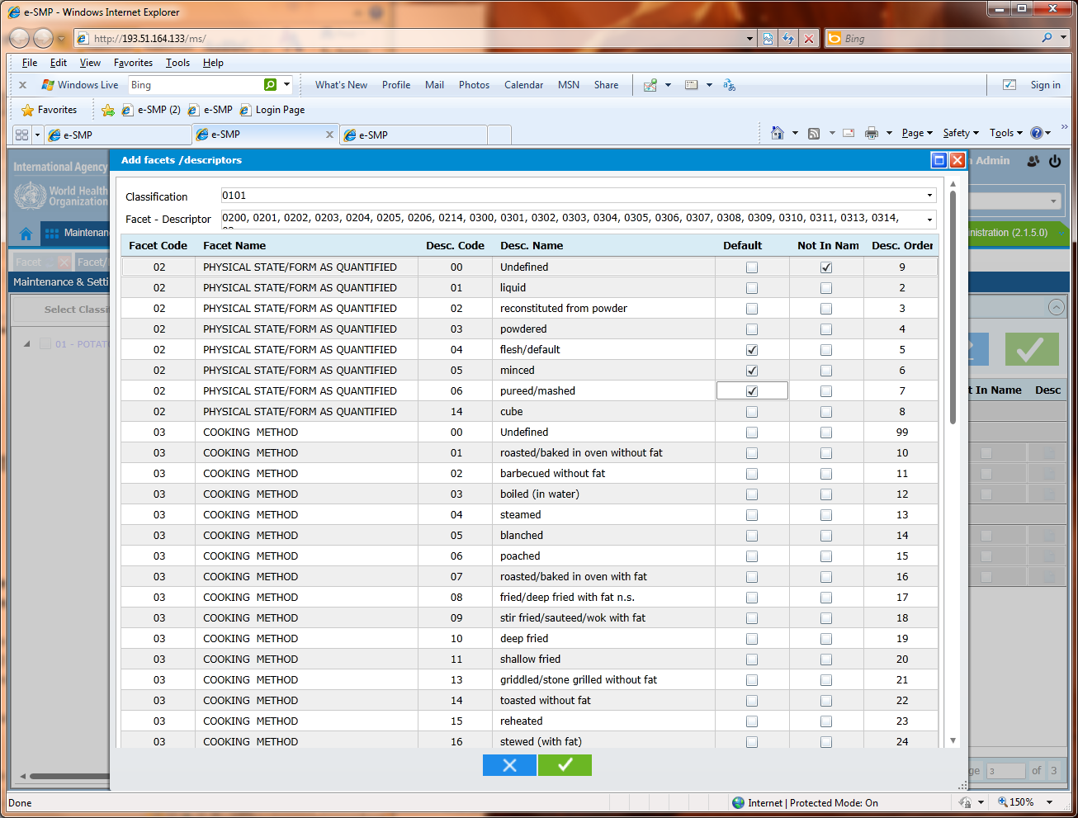
Same in the liste: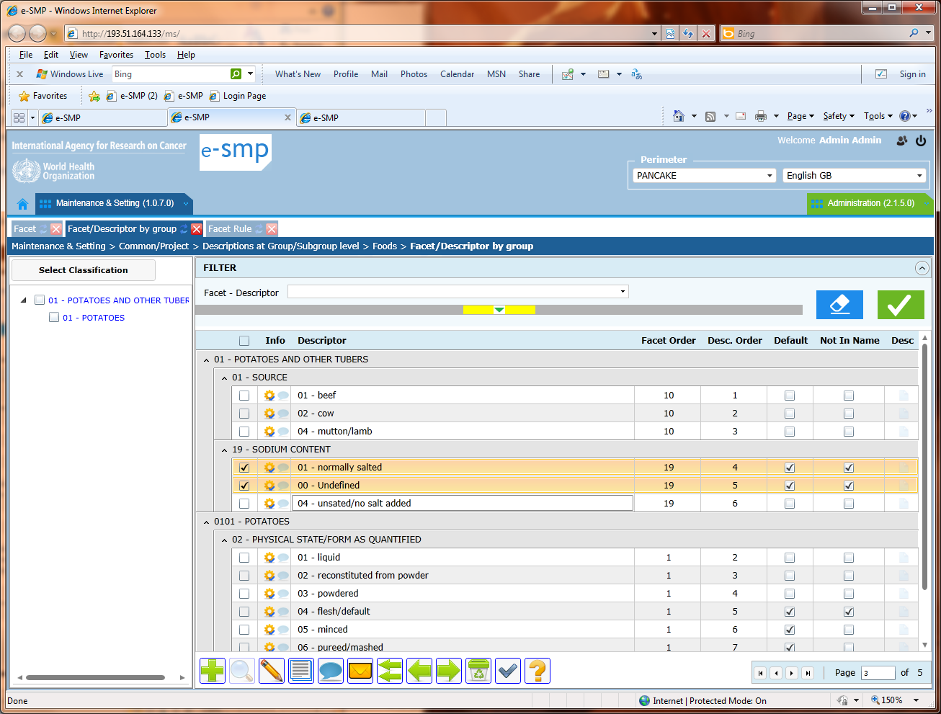

Facet per food (Country level) & proposed food list:
e-SMP-3620 | Bug | Closed
In the fadebygroup at Project level, I have facets/descriptors attached to groups/subgroups 01, 0101 and 02.
In the food list, I have food for subgroups 0101, 0201 and 1501.
In the facet per food screen, the proposed foods are the ones of the subgroup 0101 only but ALL the available foods in the food list have to be displayed in this screen (not the shadows or CR)
- Foods of subgroup 0101 with facets available in subgroups 0101 in fadebygroup
- Foods of subgroup 0201 with facets available in groups 02 in fadebygroup
- Foods od subgroup 1501 without facet attached because nothing available in fadebygroup
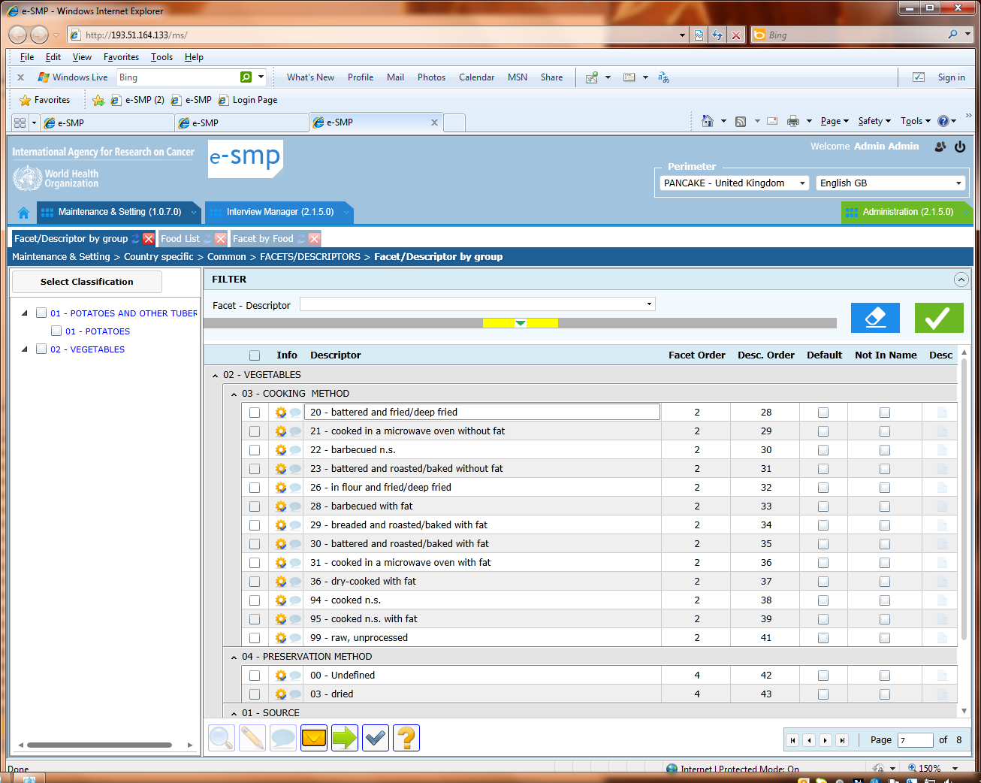

Density (Country level) & proposed food list:
e-SMP-3621 | Q&A | WIP
ALL the available foods in the food list have to be displayed in this screen (not the shadows or CR)

Food classification at project level: error message:
e-SMP-3622 | Bug | WIP
I open the screen, the list is well proposed. I select the refresh button (top of the sheet) and this error message occurred…
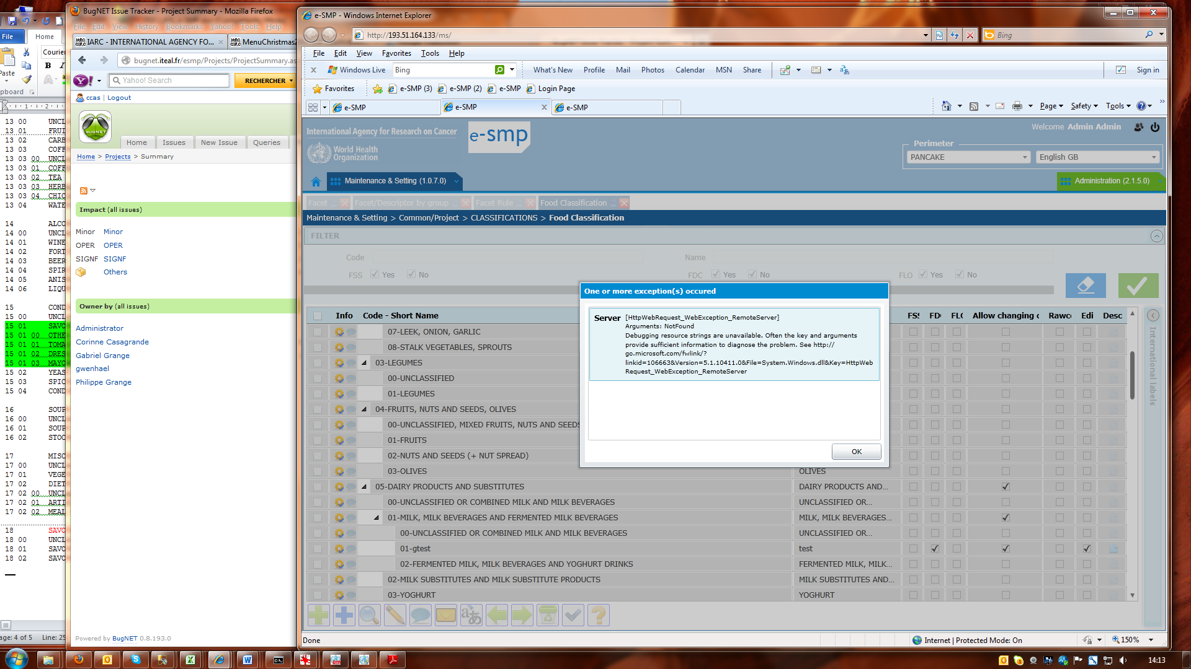

Food classification: Search on classification code
e-SMP-3623 | Evolution | Closed
In the search part, we can only search on the group or subgroup or sub-subgroup code on 2 characters that is not the most useful at the user point of view.
Effectively, we prefer to search on the 6 characters of the long code because it is more interesting to view all the subgroups of a group (ex: code = 07%) or all a sub-subgroups of a subgroup (code = 0701%) rather than displaying all groups/subgroups/subgroups with code=02

Food list: import from csv-file and not provided format
e-SMP-3624 | Q&A | WIP
- Can you provide us the format of the csv file with the column list and order, each column format and when needed the column possible modalities (e.g. supplement 0=no or 1=yes)
- Can you explain us, how the import runs? The already available foods in the list are kept or not? Do you have a check on the available food code in the csv, yes/no? Can we import shadows and how?
- The food list checklist file has to be reviewed by including these previous information

Food list: import from csv-file and error message:
e-SMP-3625 | To be affected | WIP
- I try to import a csv-file and regarding the lack of information on format I cannot.
The returned messages are sometimes detailed with:
“FoodNum = , Name = Yam, Type = , Supplement = 0, Order = 2, Group Code = 0100 --> The supplement is incorrect”
and sometimes not at all with:
“Line 8 --> data wrong format”.
Can you homogenise the returned messages by giving the maximum of details?
- The first line of the returned message pop-up is “The following item(s) was imported with error:” but in fact no new food has been imported.

Food list: Fiche
e-SMP-3626 | Tobe affected | Closed
ORDER: The order field has to be delete in the fiche because is automatically attributed regarding the rule 2 of the checklist “Values of Column Order are automatically generated: If Type = 'GI' then Order = 1 else Order = 2”. This field has not to be displayed.

Food list: Fiche
e-SMP-3627 | Bug | Closed
CLASSIF: the proposed list of groups/subgroups is not sorted on long code. See example below:
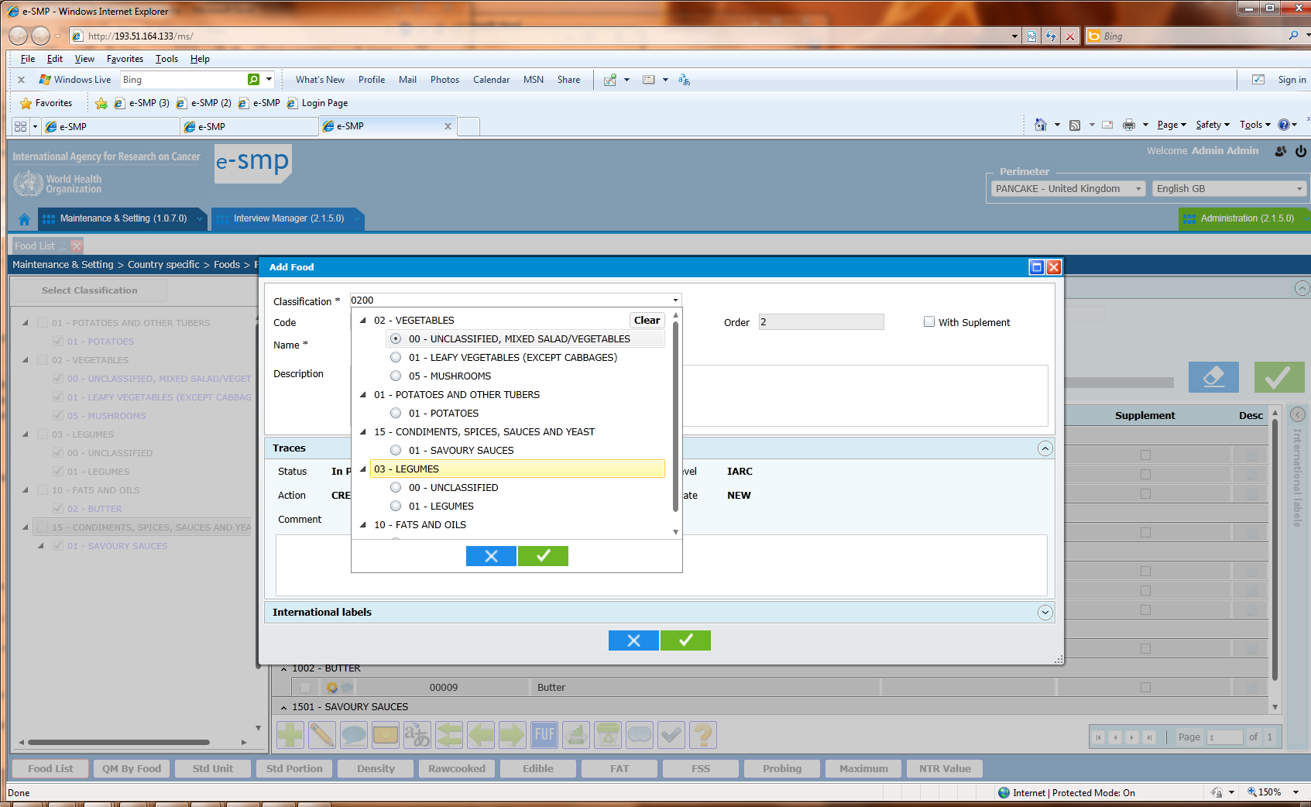
Food List and food type=CR
e-SMP-3628 | Evolution | Closed
In the search part of the list and in the fiche, the type can be egual to CR but in the checklist we do not specify it. We don’t want to keep the type=CR modality that is coming from MS-DOS version of EPIC-soft and it is no more used.

Food list – liste and sort order
e-SMP-3629 | To be affected | Closed
The list should be sorted on the classification + Name + type and not on the code as it is now.
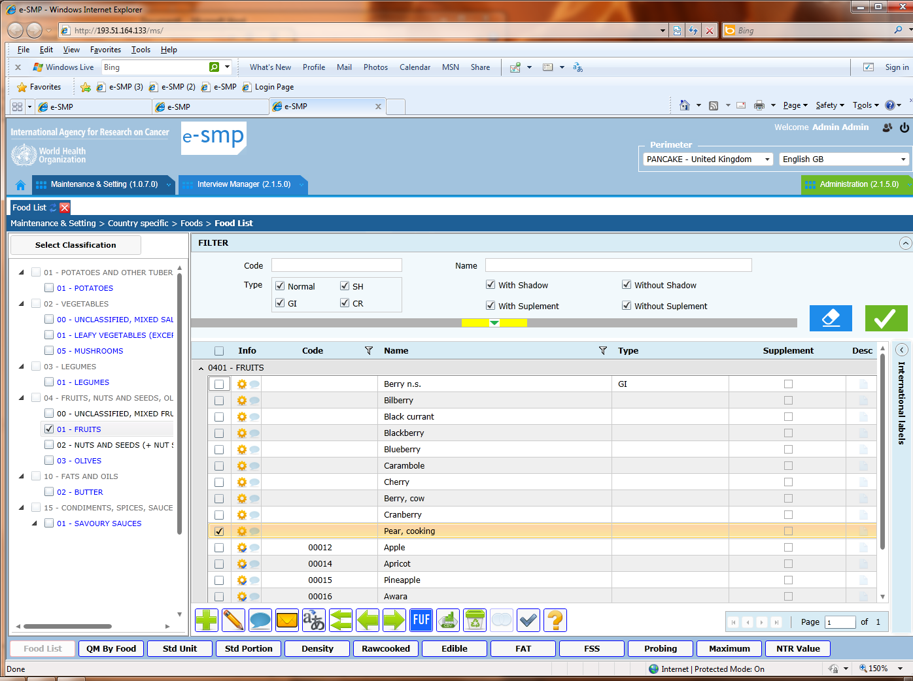

Food list - fiche and column sort
e-SMP-3630 | Evolution | Closed
When we sort on the column Name, the food name is sorted within the groups/subgroups but also the groups/subgroups are sorted on the name… this is not relevant. The sort on the column name should only sort the food name.

Food list – fiche: classif field and proposed value (3607 from Philippe)
e-SMP-3607 | Evolution | WIP
In the classification screen, the add button allows to enter a group or a subgroup or a sub-subgroup depending on the focussed record (selected one before the add).
In the facet/descriptor screen, we use the same approach to add a facet or a descriptor.
In the food list, we will appreciate (particularly the users that have to enter 2000 foods) that the proposed classification takes into account the focussed record. The rule is:
If 1 record is selected in the list and the add button is selected, and then in the fiche, the proposed group/subgroup/sub-subgroup is the same as the selected record.
If several records are selected in the liste, then 0100 is proposed.

(2012_11_12)
3647 Library level and language in perimeter not English: Fiche and proposed languages
Example with Special diet at Library level: fiche
e-SMP-3647 | Evolution | WIP
My perimeter is Library language=French
I add a new special diet. The Name is asked in English. The field Name in French is empty. I can put my cursor on it but I cannot enter something. I have to use the International labels to enter my French Name even if it is in my perimeter…
- Please can you open this “Name French” field in order to allow the user to enter the French name without moving to another part?
- Same thing when we are in edit special diet, the “Name French” field should be updatable.

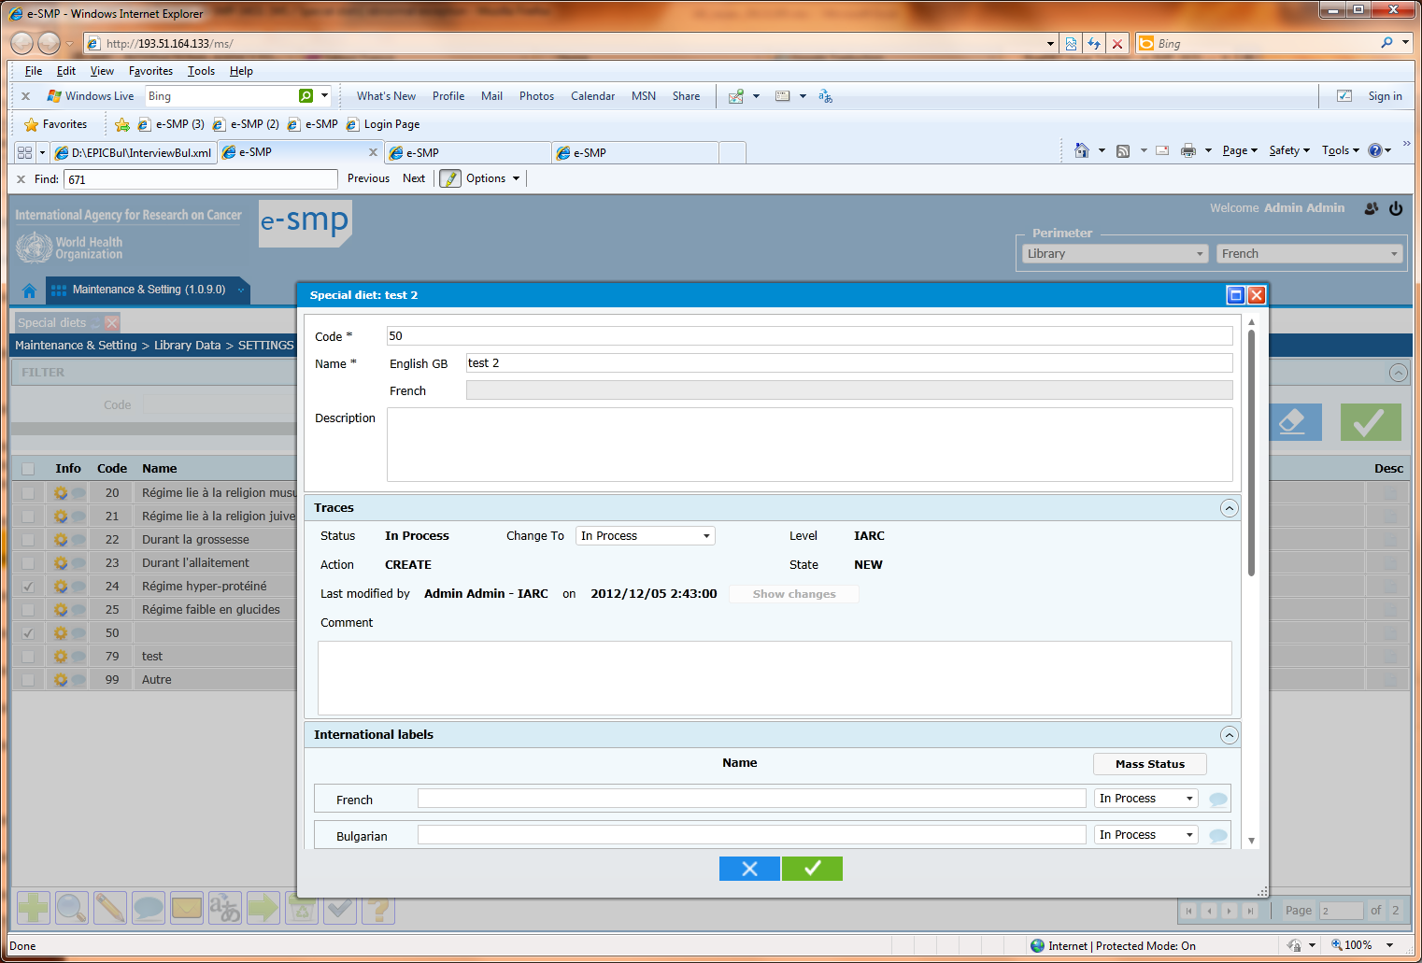

3648 “Mass update comment & status” pop-up: error message “you must select a status..”
e-SMP-3648 | Evolution | Open
I select one or several records. I select the comment button. The “comment & status” fiche is displayed. After a quick look, I can see that everything is correct, so I do nothing and I click on the green button. The following Error pop-up is displayed saying that I must select a status or add a comment!!
This message is not relevant, if no action available in the pop-up that mean that you can close the pop-up and return in the Liste and that all. In this situation, we can use the same approach as the blue button when no action has been done.
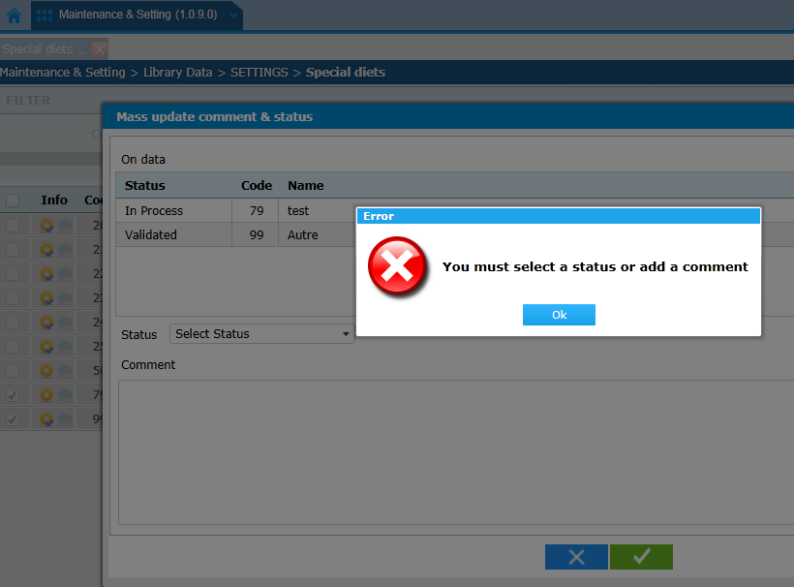
3649 “Mass Translation” pop-up: move in non-updatable columns
e-SMP-3649 | Evolution | Reviewed
Using the tab or shift tab keys or the mouse, we can move to the 3 left columns (“Info”, “Code” & first “Name”) and also we can move to the column Level. As these columns are not updatable, please suppress the possibility to move on them with the mouse and other keys.

3650 Export in csv file: File name
e-SMP-3650 | Bug | Reviewed
Can you change the format of the export date specified in the export file name with “yyyymmdd” format?
Can you also suppress the label “log_file” that is not relevant for csv export file?
For example, instead of “MS_SETTING_SPECDIET_LIST_Log_file_05 December 2012.csv”, we prefer to have “MS_SETTING_SPECDIET_LIST_20121205.csv”

3651 International Labels at library level:
e-SMP-3651 | Q&A | Open
- At library level, how do you select the displayed languages on screen (list and fiche)?
In Administration, I have 24 active Languages.
In Library (e.g. special diet screen), only 16 languages are available.
If I deactivate a language in administration, the language is still available at Library level.
If I suppress the link between Project/country and a language (e.g. Indonesian), the language is still available at Library level.
Please, can you clarify this point explaining the used rules?

- In the Perimeter when I select Library, 17 languages are proposed. Why 17, not the 24 active languages as in administration, or not the 16 languages of international label???

3494 Controls
e-SMP-3494 | Evolution | Open
An example to explain why it is not manageable as it is today. In this example, the returned message is not useful. Which items are not translated? Which items are not validated at translation level? Regarding the number of items + attached translation at Library level, how the user can do?

3652 Record selections: special situation for the second, third… pages of the list:
e-SMP-3652 | Bug | Reviewed
In the first page of the list: we select several records then we select a function as “sent e message” or “comment & status” and the attached pop-up is displayed. When we exist of the pop-up, the previously selected records are still selected
In the second, third… page of the list: we select several records then we select a function as “sent e message” or “comment & status” and the attached pop-up is displayed. When we exist of the pop-up, the previously selected records are no more selected.
- The rule is not the same depending on where we are focussed in the first page or in the other pages.
It is very important to be systematic. So we want to keep the same approach as for the same page. Selected records have to stay selected.

3653 Anthropometric: Mass update of status not possible
e-SMP-3653 | Bug | Reviewed
I select several records and I select the “comment & status” button. The pop-up “Mass update of status…” is opened. I change the status from in process to validated and I have the following error messages but it is not true the records are not in double if we take into account the “variable” column (Heigh or Weight).
It was possible to create it, but not to change theirs status.
Same problem/error message, when I open a record fiche and save it. In this case, it is because the records attached to “HEIGHT” are all opened with the wrong value in Variable field (=”WEIGHT”).
Note: The key variables in this screen are : “variable”, Sex, Min_Age & Max_age

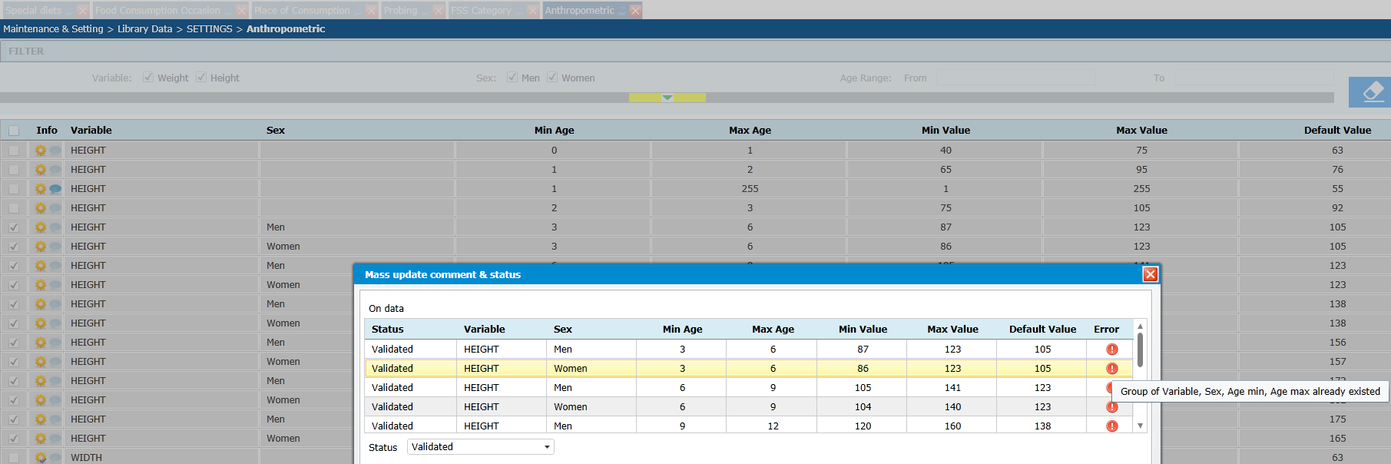

3654 Anthropometric: Values of Variable (no WEIGHT no WIDTH)
e-SMP-3654 | Bug | Reviewed
The Variable value “WIDTH” is not correct. We want WEIGHT and HEIGHT as possible values, nothing else and no translation possible

3655 Nutrient list: field “display in the ‘nutrient’ screen”
e-SMP-3655 | Evolution | Reviewed
The default value should be “not checked” as below.
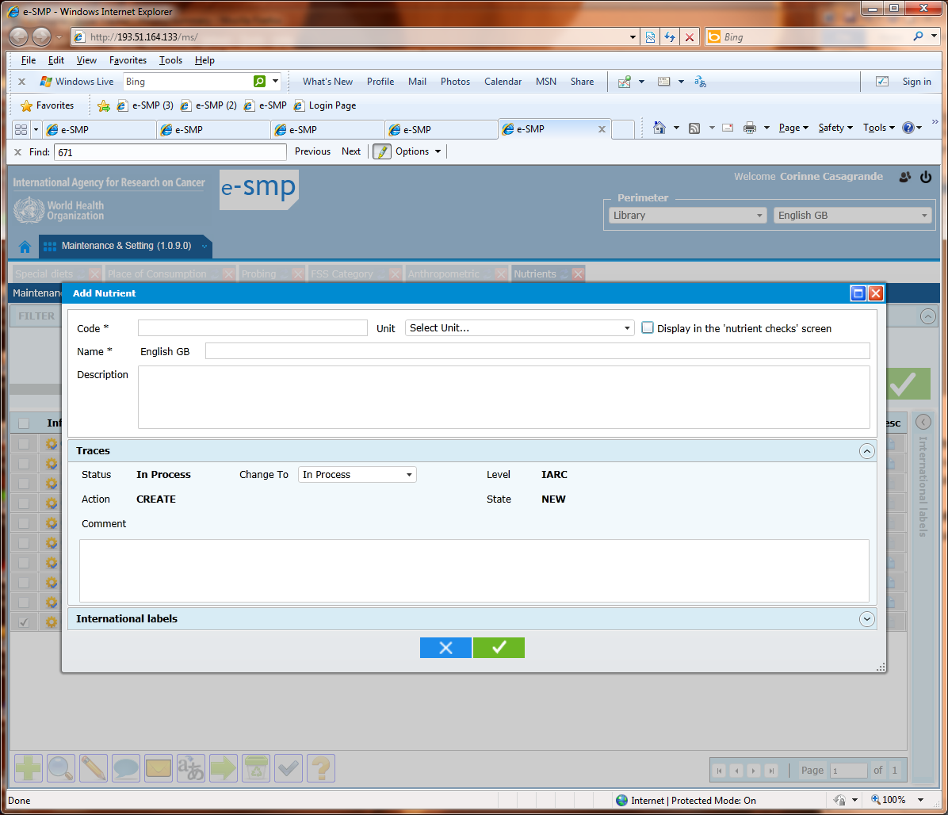

3657 Nutrient export: column “display”
e-SMP-3657 | Bug | WIP
Why the values of this column are true/false and not 0/1 as defined in the databases?

3658 Note status at Library level: Column order
e-SMP-3658 | Evolution | Closed (after 5 back and forth)
What is the column order? It should be done on the code
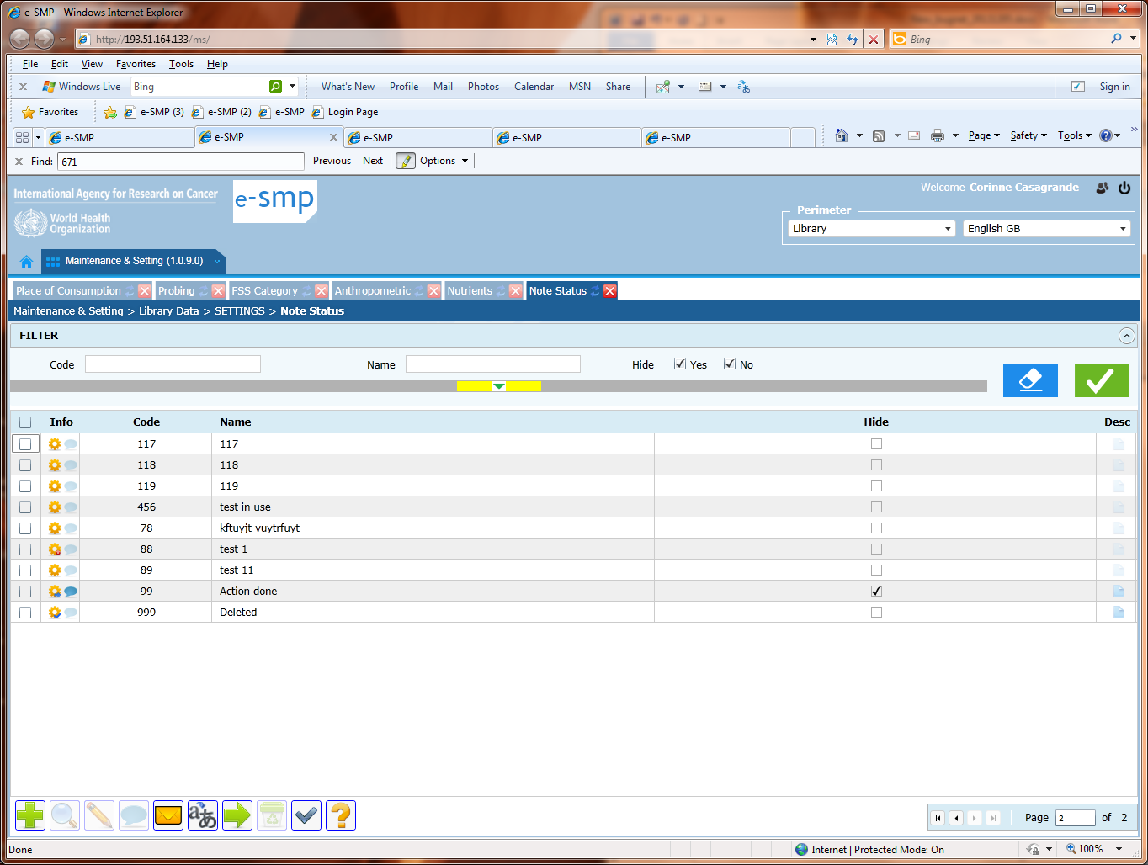

3659 Note status at Library level: Controls
e-SMP-3659 | Bug | Reviewed
The error message is not correct. The rule is “The following S_code values are mandatory:
‘00’ with label 'New',
‘99’ with label 'Action done'
'999' with label 'Deleted'
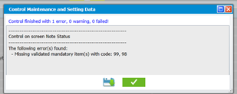

3656 MASS translation: Column Info
e-SMP-3656 | Evolution | Open
- In the mass translation pop-up, the column info should display the status of the record not the status of the translation that is already available in the status column.
- When we move the cursor on this column, the tooltip is not displayed
- The sort on the column Info, is very important in this pop-up. Effectively, the user has to order the records in order to pay attention on the validated records.
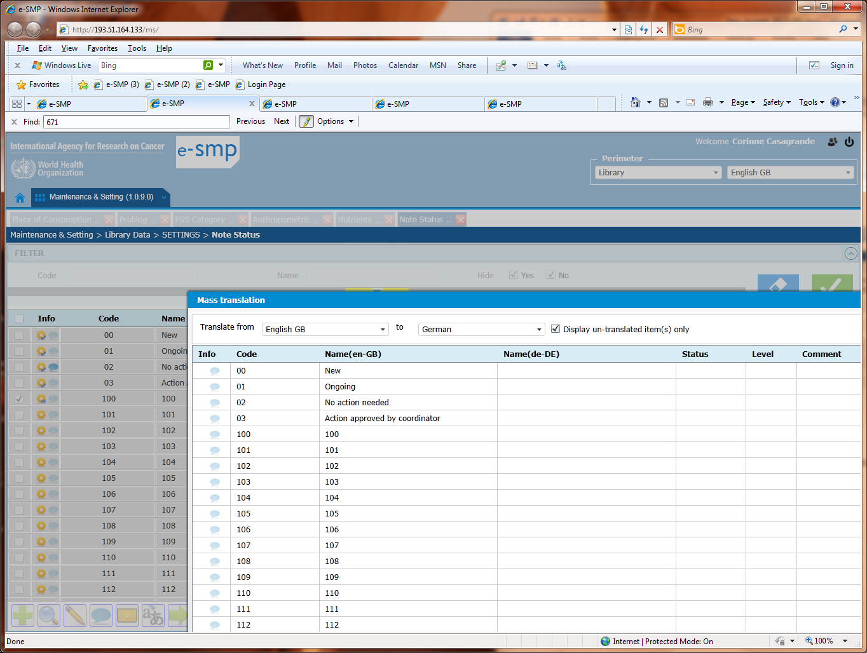

?? Check list per FCO:
I edit a record (status=in process, state=new) but I cannot modify the FCO code. Why? This is not relevant.
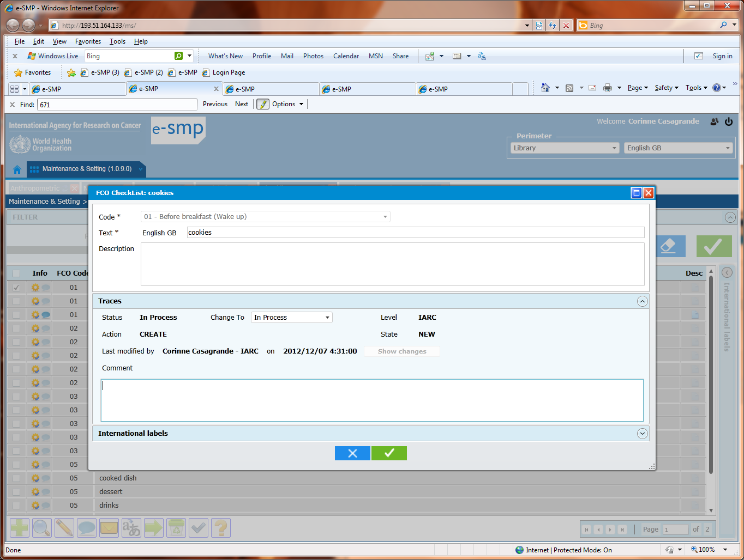

3662 Check list per FCO: Fiche
e-SMP-3662 | Evolution | Reviewed
Can you change the label “Code” by FCO?

3663 Check list per FCO: FCO label
e-SMP-3663 | Evolution | WIP
In the fiche the FCO code + label are displayed. As we have space, the FCO label has also to be displayed/available in:
- the liste (as in the fiche: “01 - Before breakfast!”)
- the export as an added column
- the message (e-mail) as an added column

3664 Check list per FCO: Controls
e-SMP-3664 | Evolution | Open
The error messages are not understandable, which records?
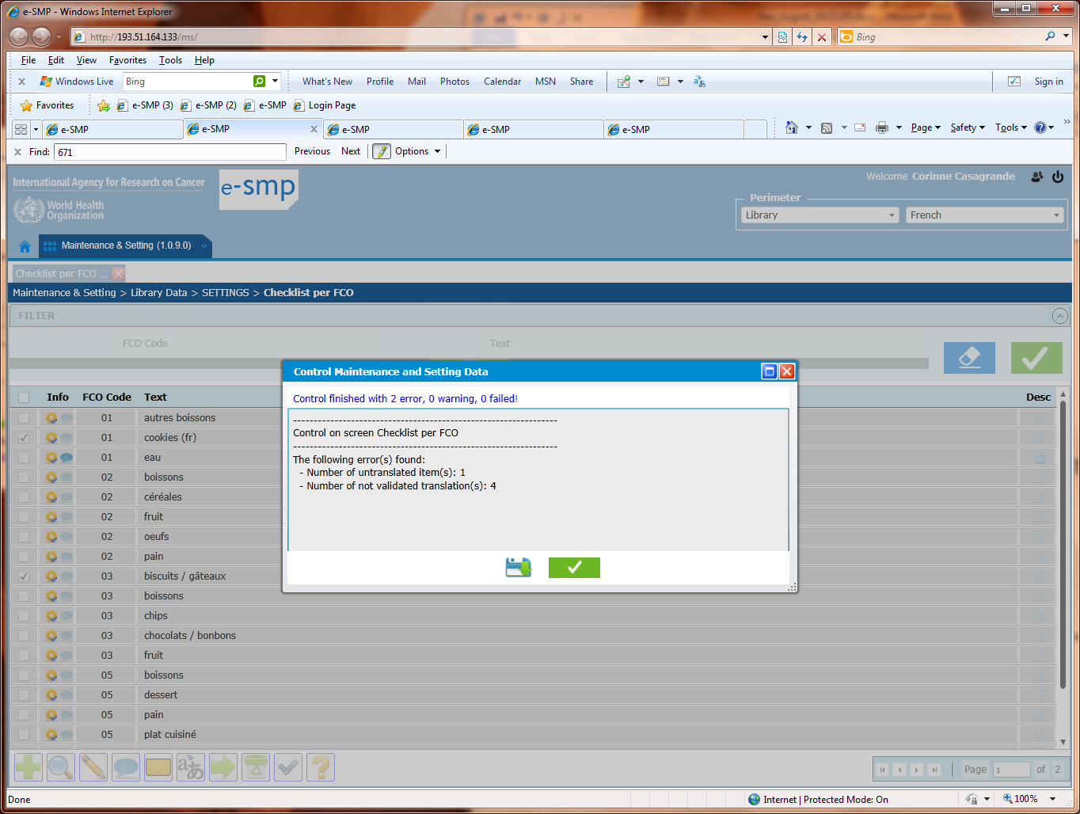

3665 Mass translation:
e-SMP-3665 | Evolution | Reviewed
In the field “translate from” we prefer to always have English GB language proposed by default even if in the Perimeter field, French is selected. In 99% of the case, the translation is started from English GB

3667 EPICTEXT & Mass translation: sort order
e-SMP-3667 | Invalid | WIP
The proposed list to be translated is not sorted or how it is sorted?
This list should be sorted on ORDER field.
The column ORDER has to be added in this pop-up in order to allow the sort on it.

3668 EPICTEXT & Mass translation: translation for Data entry (DE)
e-SMP-3668 | Evolution | WIP
If there is no value in the column “Text for DE(en-GB)” then we cannot have values in the column for translation (here in “Text for DE(fr-FR)” column). Example with record Height, the second “hauteur” value is not possible.
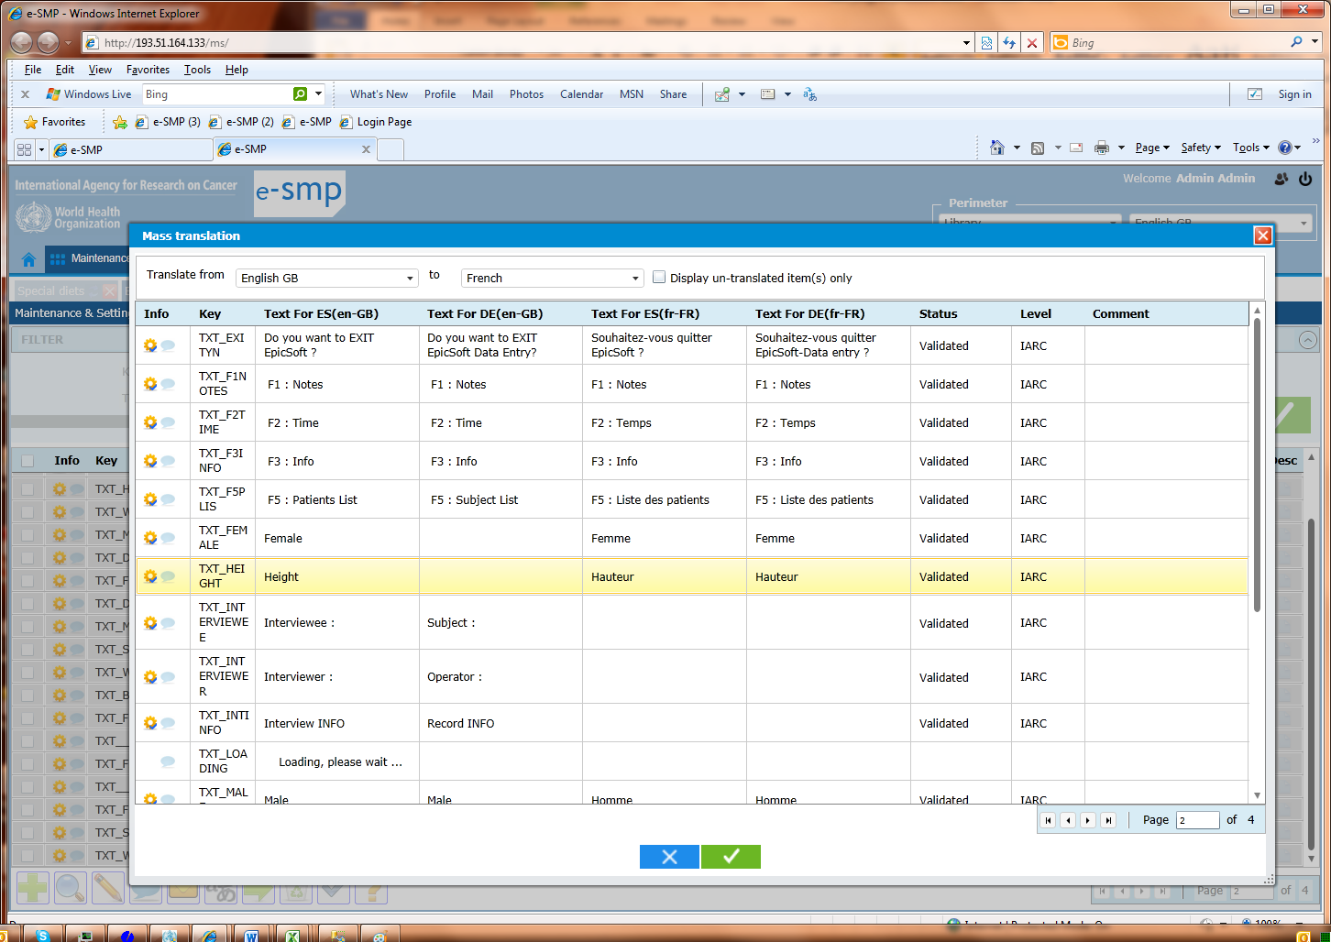

3669 EPICTEXT & Mass translation: no status on translation if empty translation
e-SMP-3669 | Bug | Reviewed
In this example, we can have validated record without attached translation???
A record without translation cannot have a translation status.


3670 EPICTEXT & Controls: no report on un-translated items
e-SMP-3670 | Invalid | WIP
Even if some records are translated and some not, in the report, they are no checks on translation status (as in checklist per FCO screen).
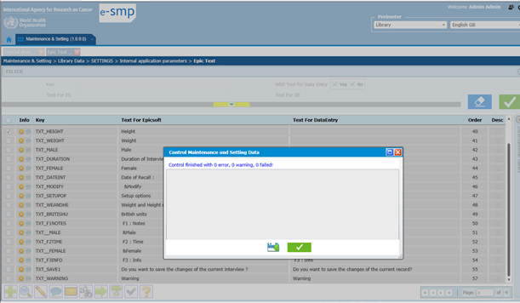
In the database:

3671 Send Alert & request to add/modify/delete: force list of “recipient users”:
e-SMP-3671 | Invalid | Closed
At Library level, when the user select a “request to add, modify or delete”, the recipient list is forced to all the users defined with IARC role and he/she cannot remove some users. This list should be proposed with the green cross and not forced.
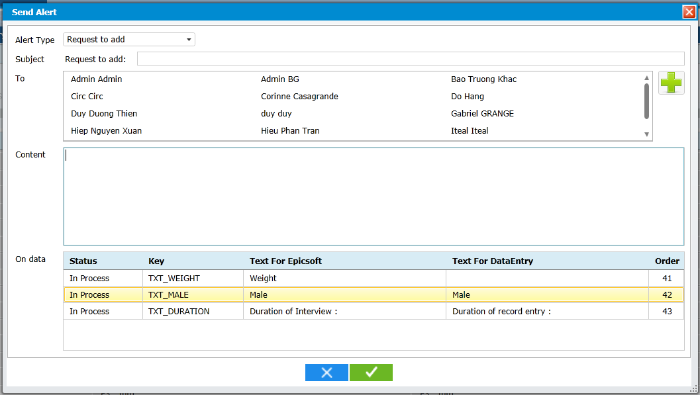

3672 Send Alert & mandatory fields: “To” mandatory field
e-SMP-3672 | Bug | Closed
When the “subject” is not filled, after having selected the green OK button, a red box indicates why the e-mail cannot be sent.
When the “To” is not filled, after having selected the green OK button, the red box is not displayed and it should be.
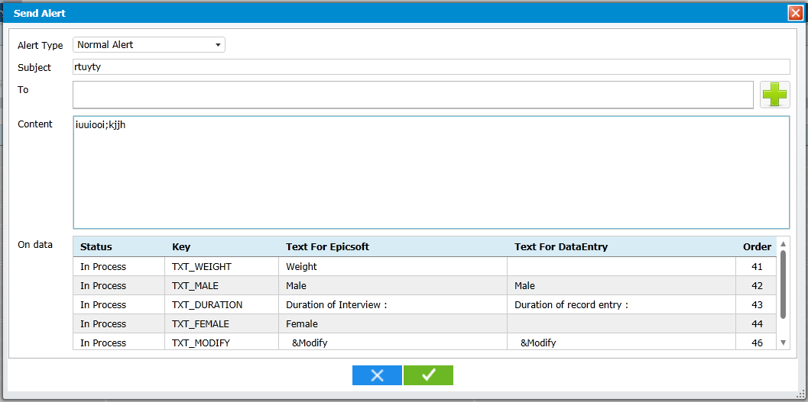

3673 Epicsoft Parameters: Fraction fields
e-SMP-3673 | Invalid | WIP
In the fields “fractions”, only fractions can be entered and it is not the case, see below.
Why the alignment of these fraction fields is in the right and not in the left?

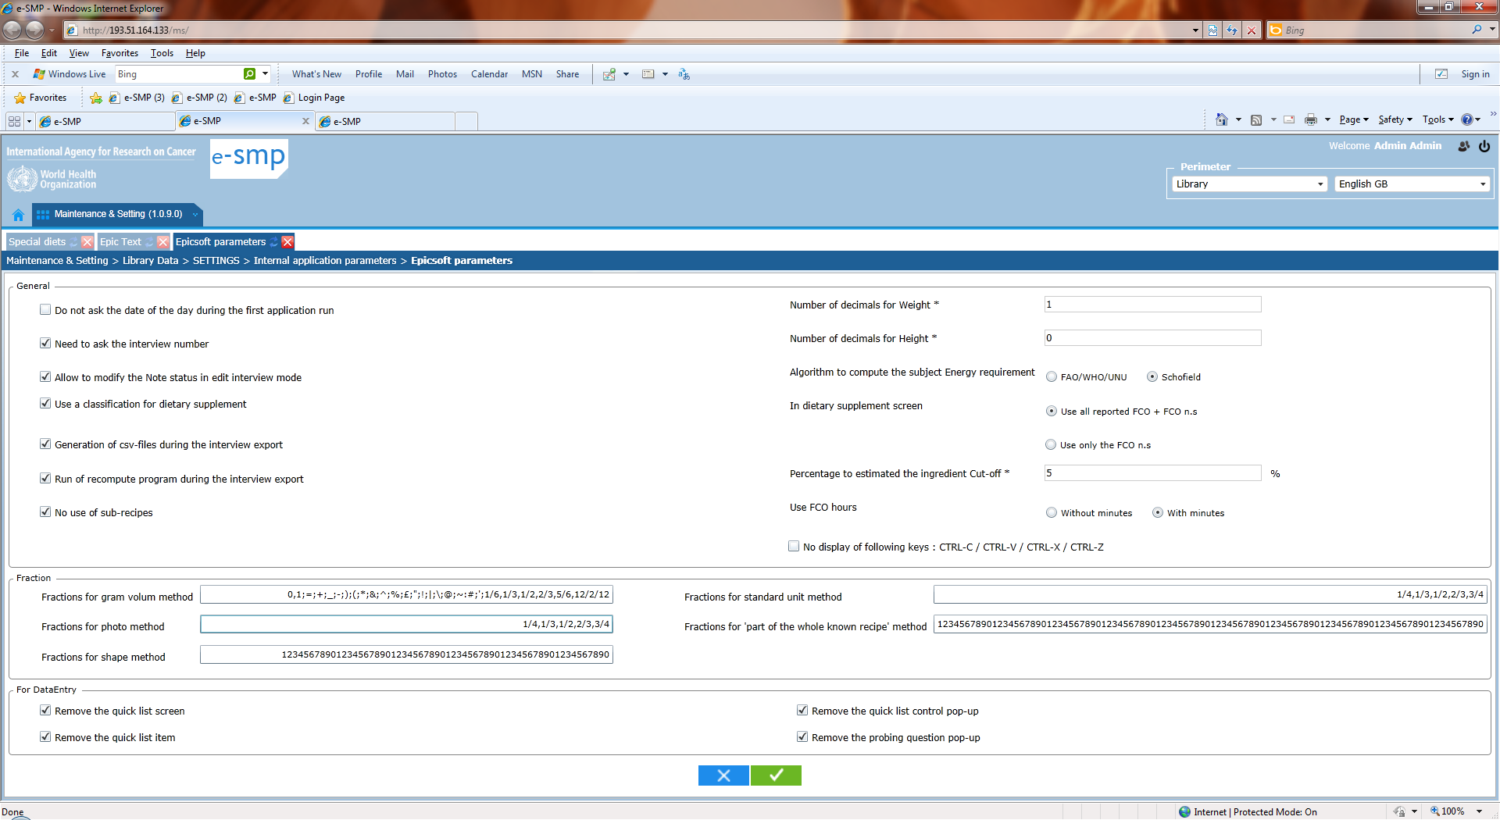

3674 Substitution liste: field “substit classification”
e-SMP-3674 | Evolution | WIP
We do not need blank between the group/subgroup. Change the value “03, 0300, 0301” by “03,0300,0301”
In the fiche, the groups/subgroups are separated with a dash (“03 – 0300 - 0301” ) and in the liste with a gomma, please use the gomma without blanck in both cases.

3675 Substit: Fiche and add a classification:
e-SMP-3675 | Evolution | WIP
- propose only the group/subgroup not yet selected
- Idem propose a substit classification not yet attached to the selected classif code.

3676 Substit: Fiche and add : Status of groups/subgroups in Classification
e-SMP-3676 | Bug | Reviewed
For the classification code, propose only the group/subgroup that are validated and not all
For the Substit classification also, propose only the group/subgroup that are validated and not all

3677 Substit: Fiche and classification fields: long display time
e-SMP-3677 | Invalid | WIP
The time to display the values of the “Classif code” fileds is too long. Idem; long display time for the Substit classification field.

3678 Substit: Fiche for Add:
e-SMP-3678 | Evolution | Corrected
A subgroup can be linked to itself (e.g. classif code=“0601” with Substit classif=“0601”). Here, it is not possible and it should be

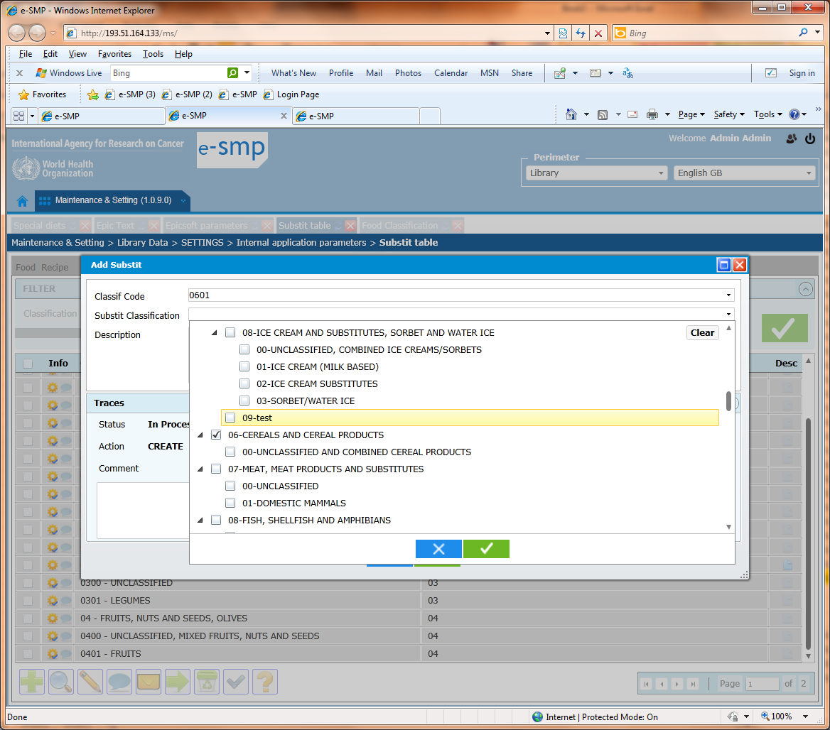

3679 Substit: Fiche and add a substit classification:
e-SMP-3679 | Evolution | WIP
In Substit classification field, if I select a group, the attached subgroups and sub-subgroups have also to be selected on the pop-up and after the ok, only the group is displayed in Substit classification field

In Substit classification field, if I select a sub-group, the attached sub-subgroups have also to be selected on the pop-up and after the ok, only the sub-group is displayed in Substit classification field

This display should not be possible:
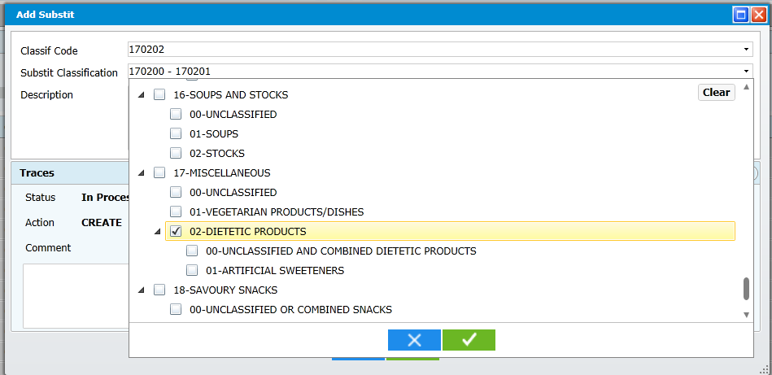
And should be replace by:
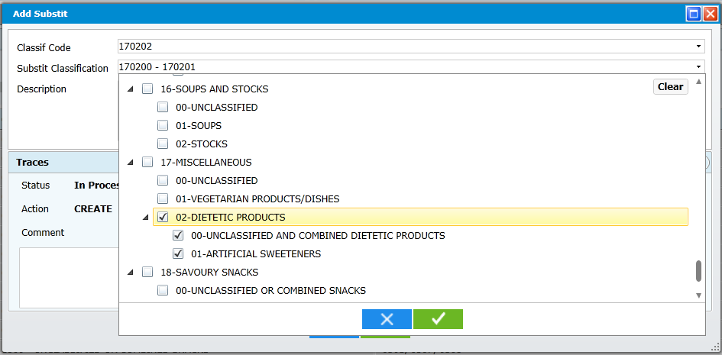
Then In the pop-up add Substit, we have:
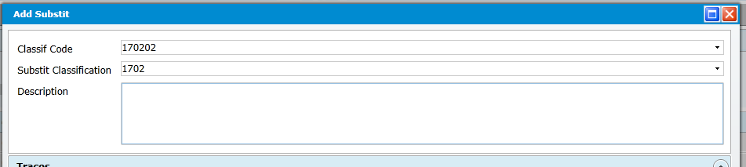

3680 Substit: export
e-SMP-3680 | Evolution | Closed
In the export file, we have only 1 column for classification code and name, please; can you separate them in 2 different columns?

3681 Substit: controls
e-SMP-3681 | Evolution | WIP
After the control run, we have the following error message but the record with the classification code 7900 is not displayed on screen?
Even if a group/subgroup is no more validated in classification table but available in Substit table, it should be displayed in Substit screen.
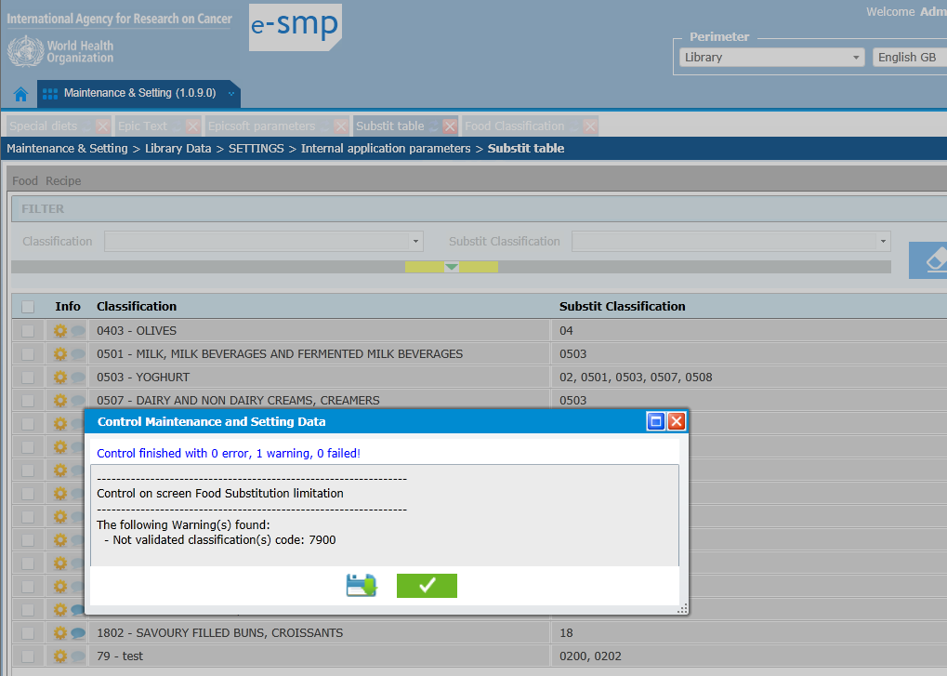
Le 27/12/2012
Improbable Descriptor: Liste and column presentation
3691
- In the list, the Group/Subgroup column should be the first one and the sort has to be done on:
Classif, Facet, descriptor and facet string
- The facet string should not be displayed with “-“ but with comas “,”

Import data (Blue cross) at Project level: Search in traceability fields
3692
The proposed records in this pop-up are only those that are validated at Library level and not yet selected at the selected project level. Why do you add the search on traceability in this pop-up? Whatever it is not working, see below when nothing has been selected (state, level, action) and the 3 records are still displayed.
Please remove this Traceability search part.
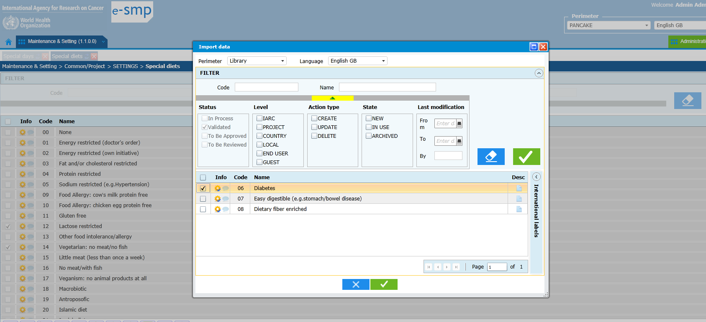

Import data (Blue cross) at Project level: Language fields in import pop-up
3693
At the top of the pop-up, if I click on Language, the list of all the possible languages available at library level are displayed but in my defined project (here Pancake), only 3 languages + English GB are defined so the proposed list should be the same as for my selected project and not all.
Same think for the “International Labels” part, only the languages defined for my project should be displayed and not all.
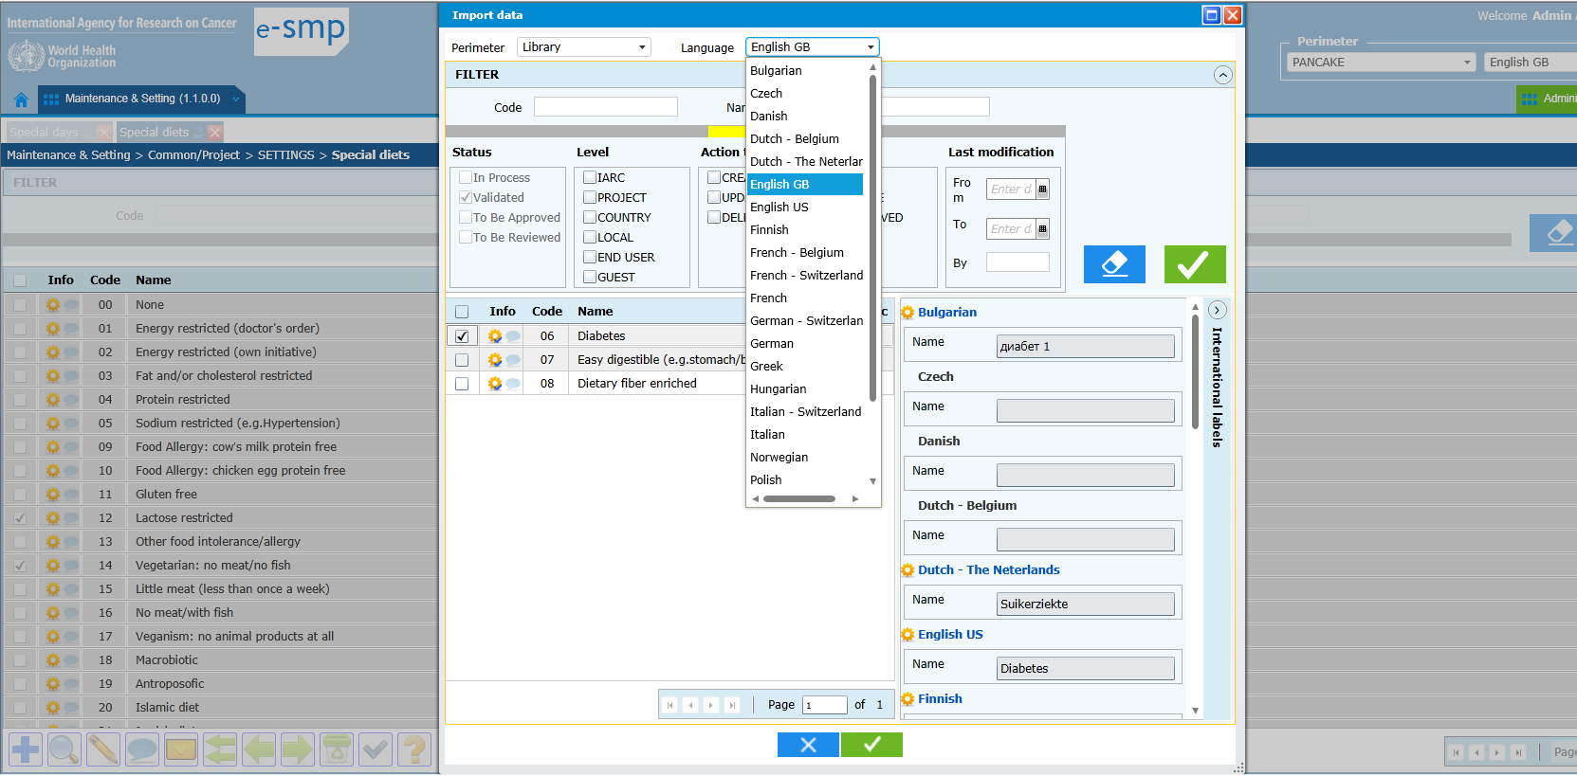

Import data from other projects (green cross) at Project level: Perimeter
3694
In this list we should have the combination of the visibility matrix and the user's authorized perimeters
The content of the list is all the perimeters defined in the visibility matrix minus the ones on which the user have no rights.
The list shown here is wrong because we can see perimeters that are not in the visibility matrix of the current perimeter.
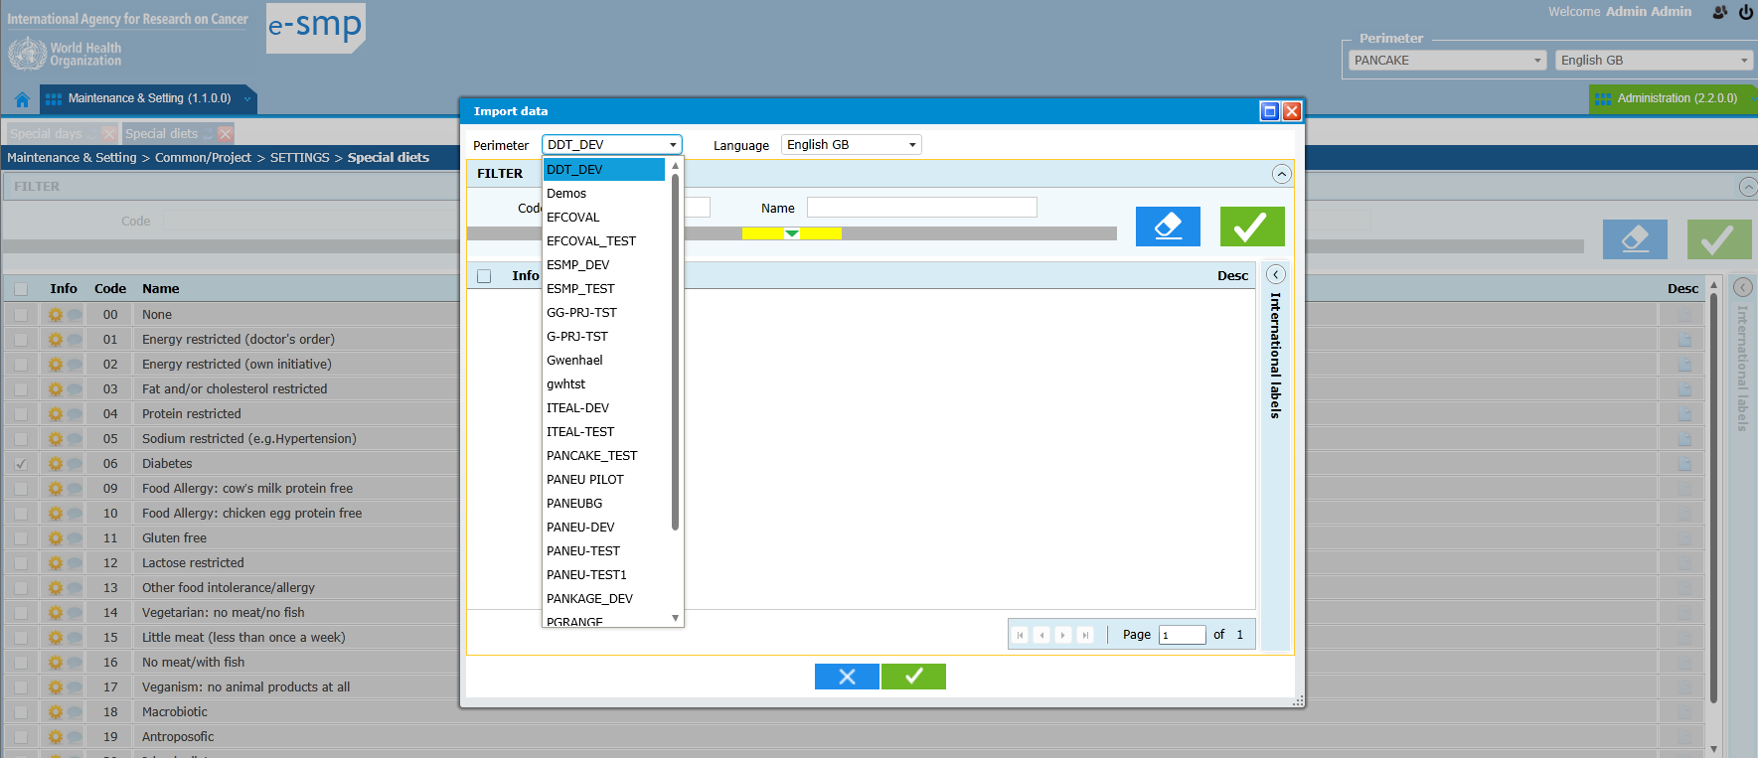

Export in csv-file with Name/label : First column name
3695
In the export, in the first column Name, the used language is the one defined in the Perimeter. If I select “French” in the Perimeter, in the export csv-file, I find twice the name in French, once in the column Name and once in the column Name(French) but the Name in English GB, the main language, is not available.
Example with the “Special Day” export at Library: list of available Name columns
Name
Name(Bulgarian)
Name(Czech)
Name(Dutch - Belgium)
Name(Dutch - The Neterlands)
Name(English US)
Name(Finnish)
Name(French - Belgium)
Name(French)
Name(German)
Name(Hungarian)
Name(Indonesia)
Name(Italian)
Name(Norwegian)
Name(Polish)
Name(Portuguese)
Name(Vietnamese)

Classification at project level: Translation at Project level
3696
At the Project level, the Name translation (using mass translation and international label functions) can only be done for added sub-subgroups in the selected project.
The group/subgroup translations can only be done at Library level.
At project level, only some sub-subgroups can be added (according to the condition “allow changing child group”=yes) so these added sub-subgroups will have to be translated too.
Here we can translate everything:
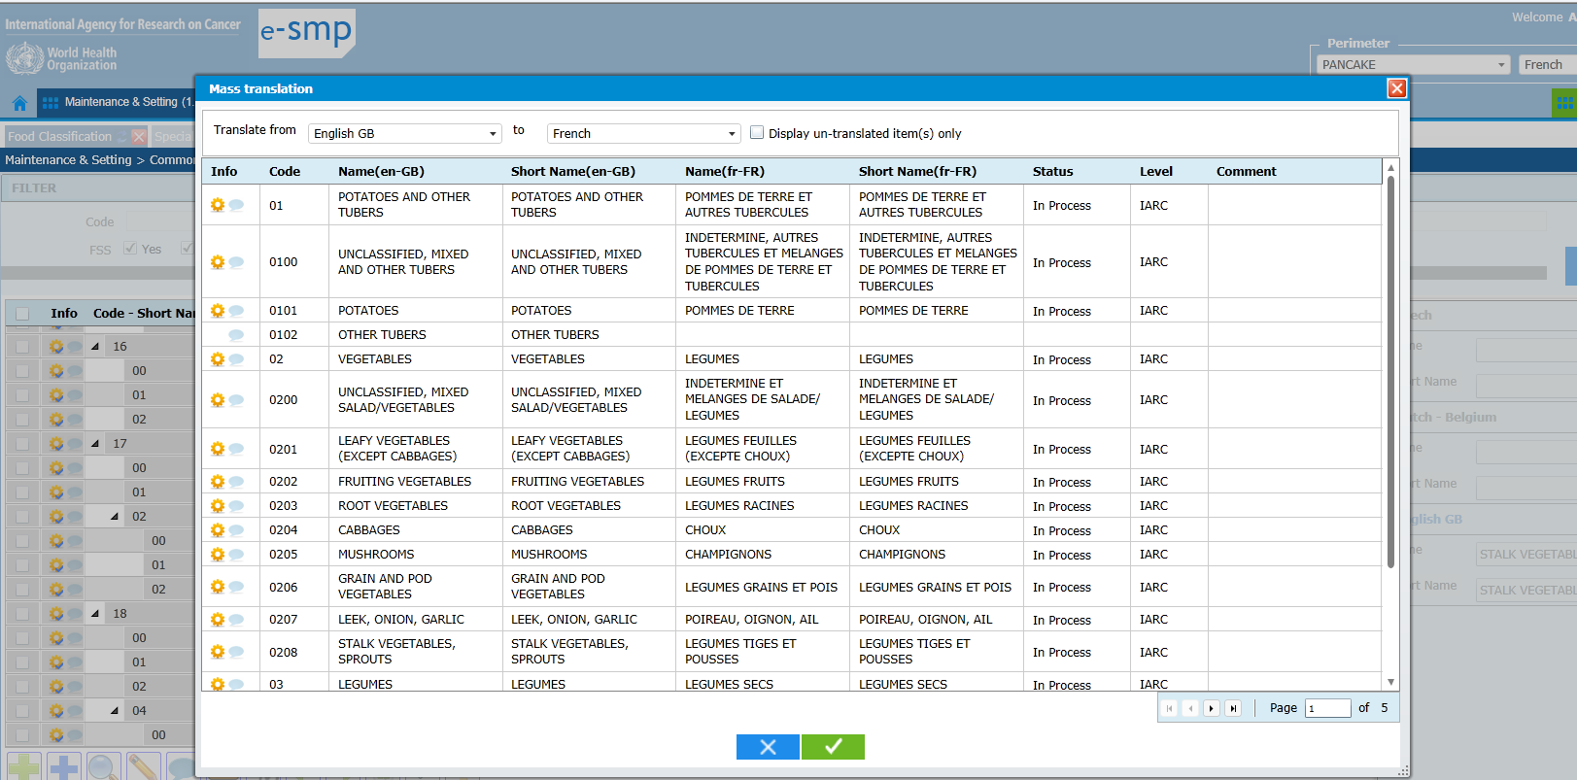

Note status screen at Project level: Add records (green cross) & not possible Update
3697
I add a new note status using the green cross. Then I edit it, the fiche is displayed but I cannot update it? This record is not coming from Library so I can have the possibility to change it.
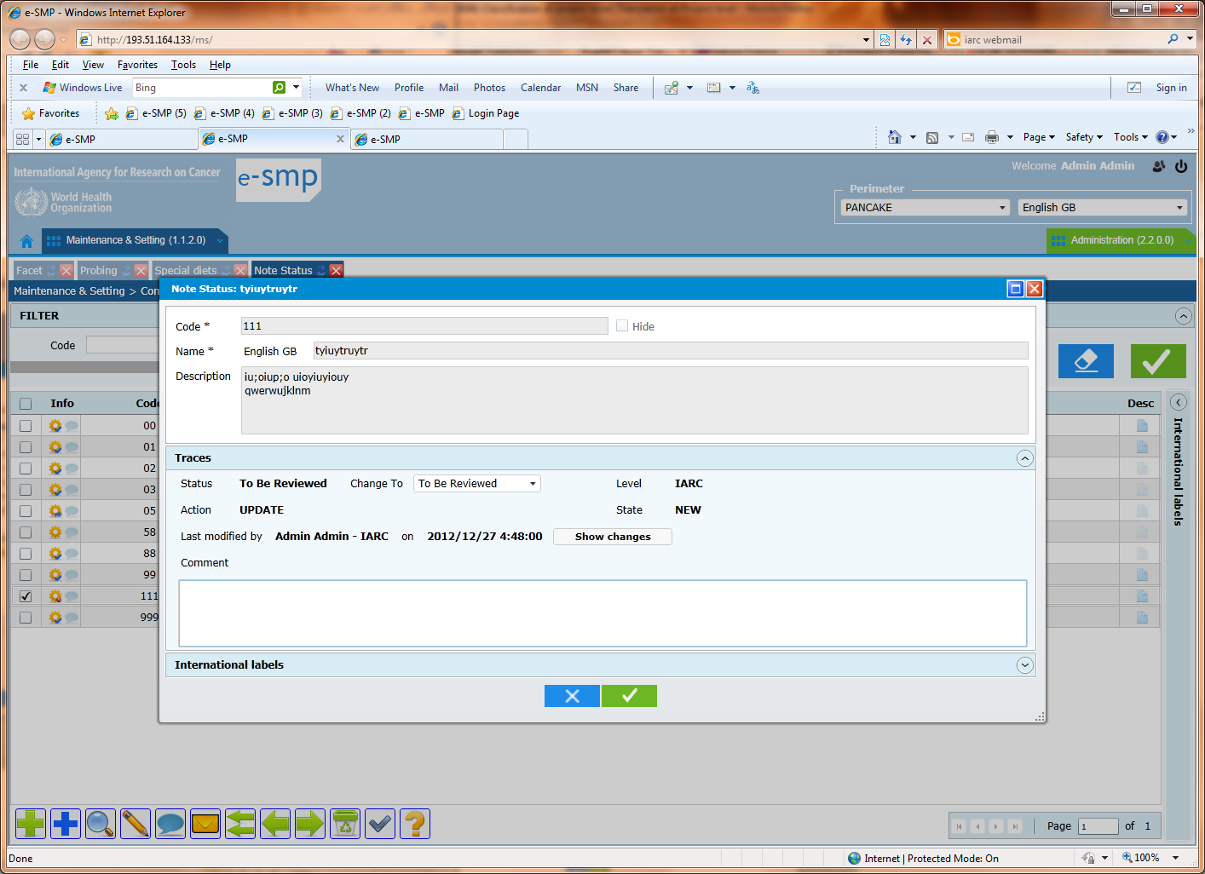

Note status screen at Project level: Add records (green cross) & not possible Update
3698
When I edit a record, I can select the “Show changes” button but the Revert button is not available and it should be.
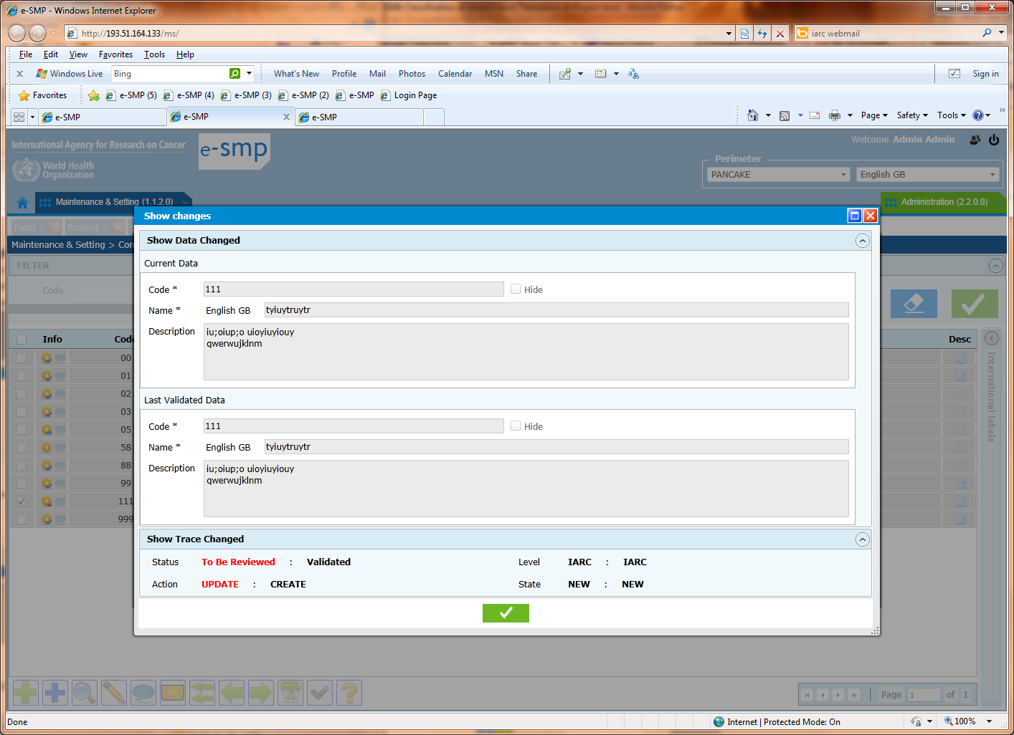

Facet Rule at project level: problem of presentation
3699
a) The presentation is not what we need; facet column should be before descriptor column. For a user, he/she decide first on which facet the rule need to be applied and then he/she defines the rule selecting the descriptor.
b) Label next facet should be replace by “facet”
c) Column “facet-descriptor”: can you add the descriptor label please? It is strange to have the facet name available but not the descriptor one in the same Liste 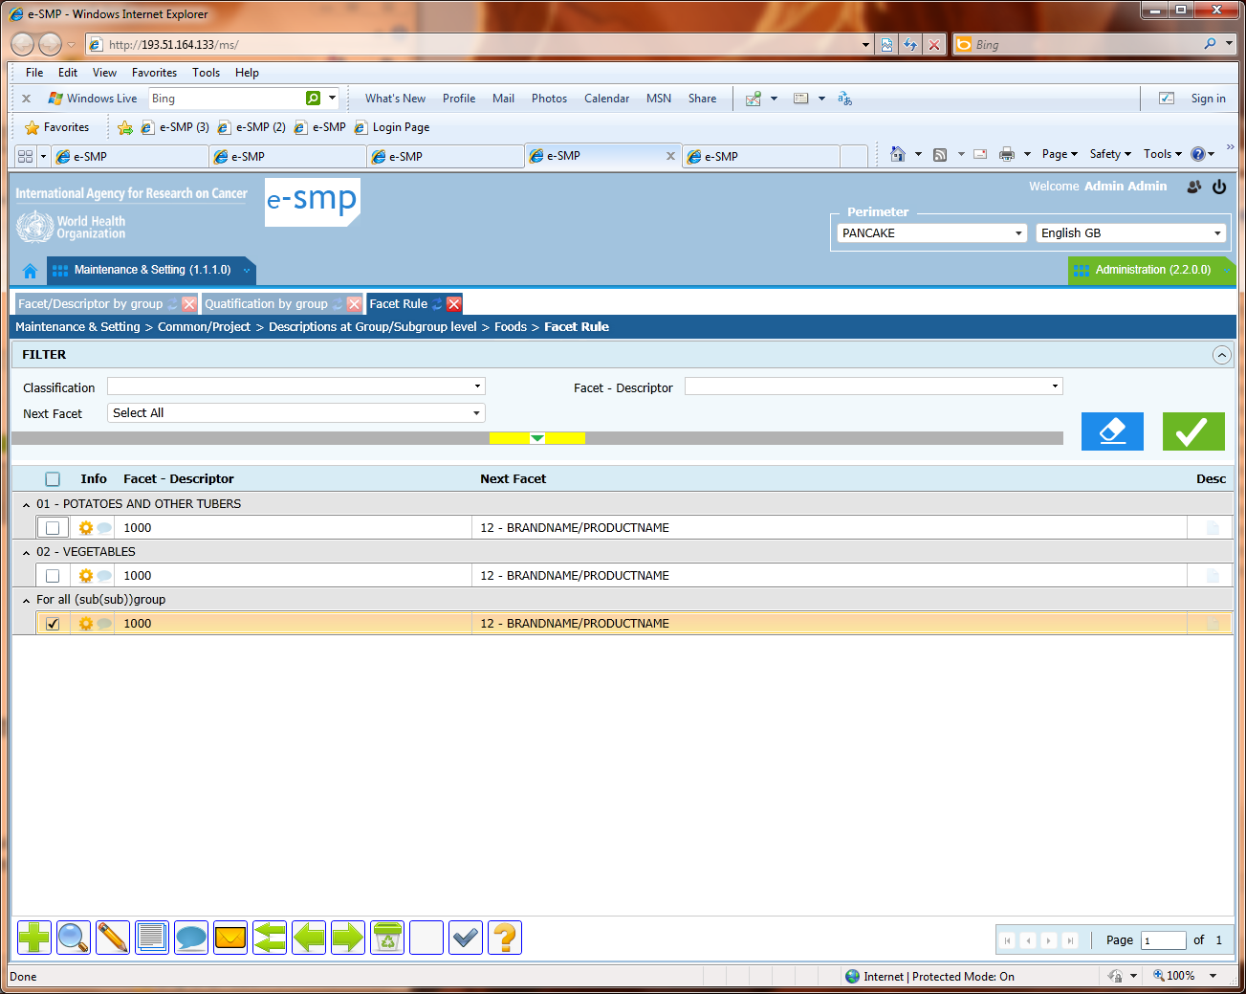
FDQMDETAIL: Fiche and “raw cooked” field
3700
In the fiche, it is not possible to change the value of “Raw cooked” field. Why always cooked? Can also be raw or both.
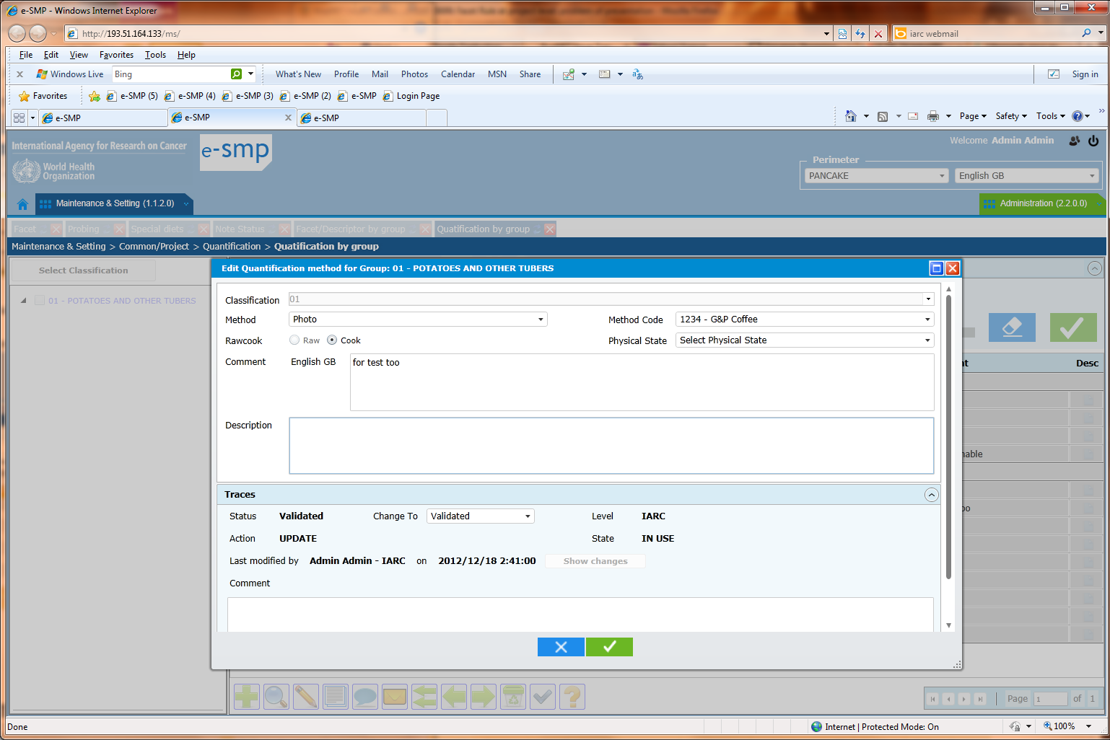
FDQMDETAIL: rule of Unicity
3701
A method cannot be selected twice with a physical state and without physical state:
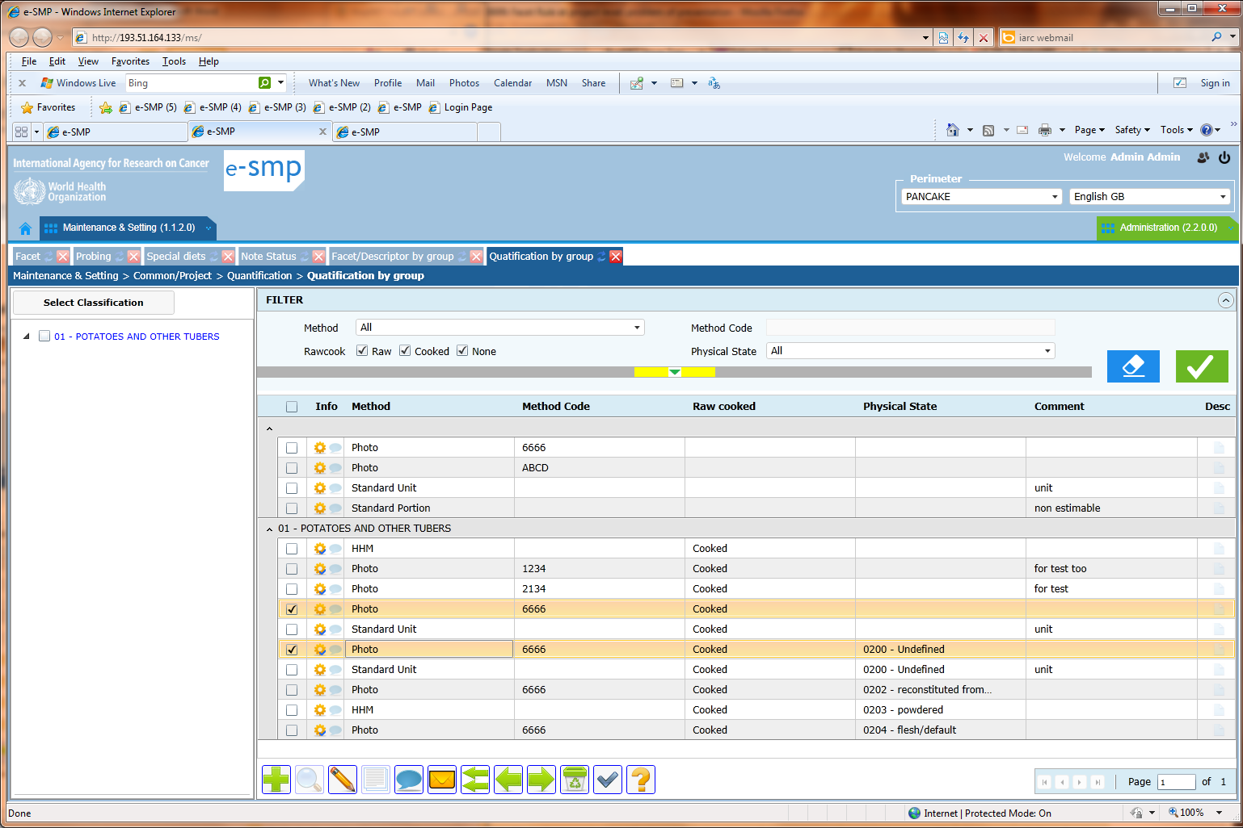

FDQMDETAIL: (Quantification by group and Import from other project )
3702
- Import from other project (1 green arrow) is not working correctly. I select the “gwenhael” project and several quantification methods and do OK. Then in the list I have these methods available but without attached to groups/subgroups?
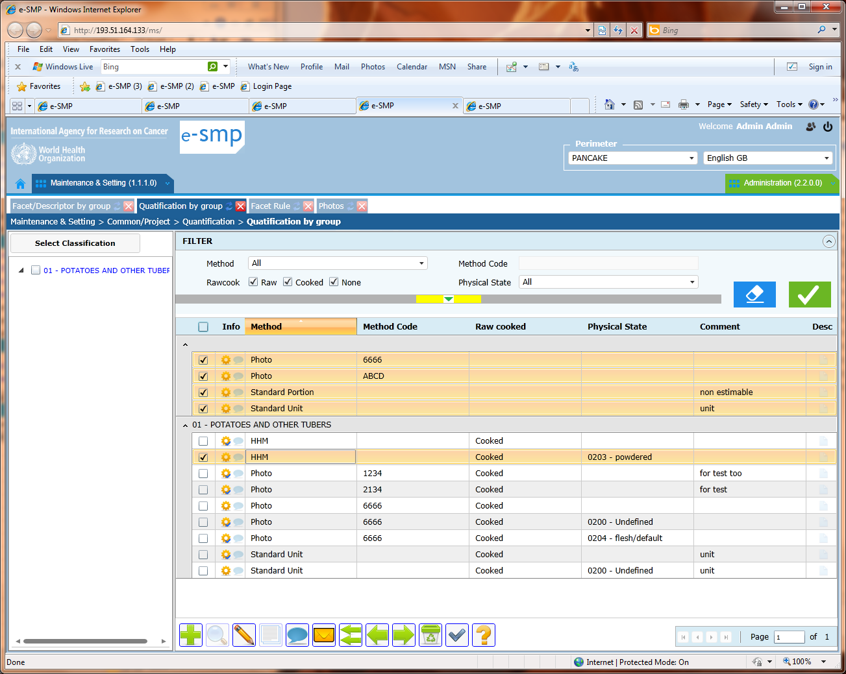

Probing by group/subgroup at Project level:
3703
- At the bottom of the screen, we have functions attached to the food part at Country level???
- The title of the screen is not food probing but “Foods: Probing by group/subgroup”
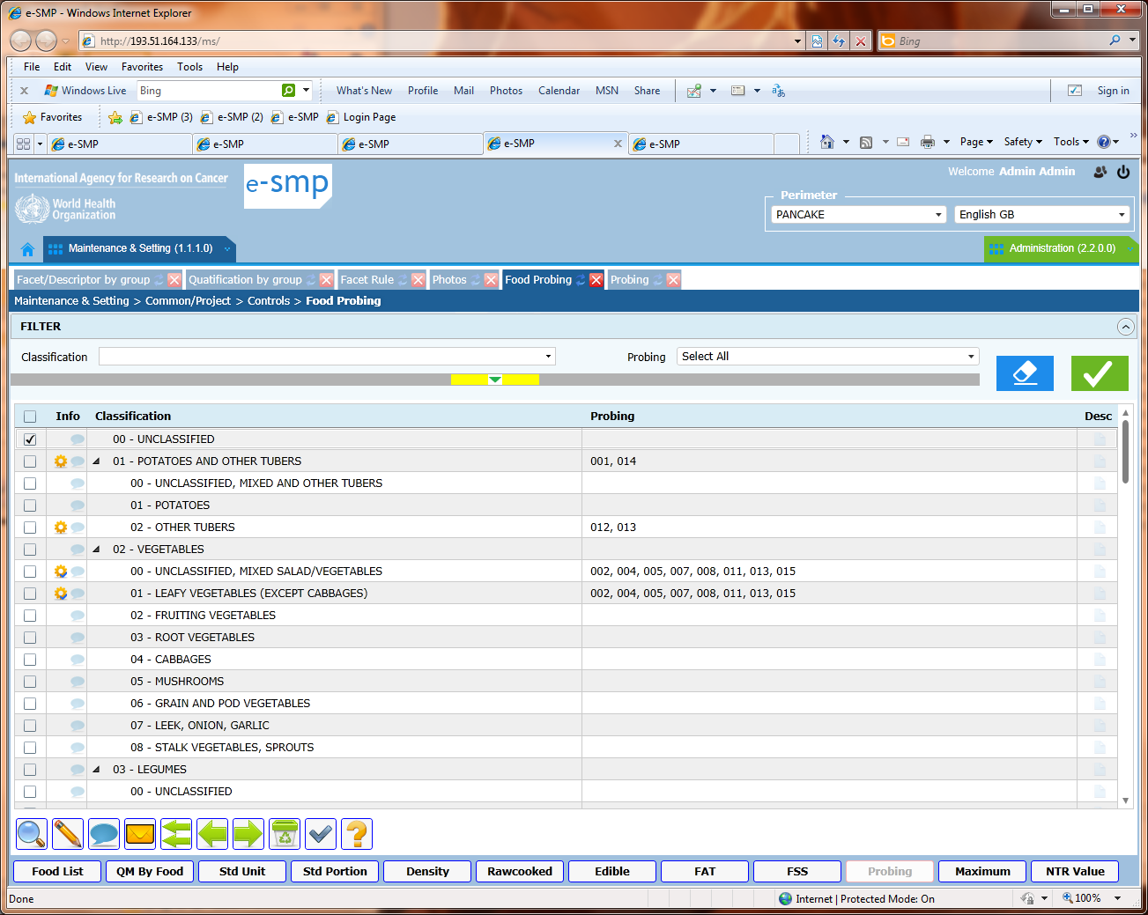

Probing by group/subgroup at Project level:
If we have probing attached to a group, it is not necessary to have probing attached to the linked subgroups. Idem if probing are attached to a subgroup; we cannot have probing attached to the linked group.


Probing by group/subgroup at Project level: Import (green arrow)
3704
Import returns (green arrow) an error message:
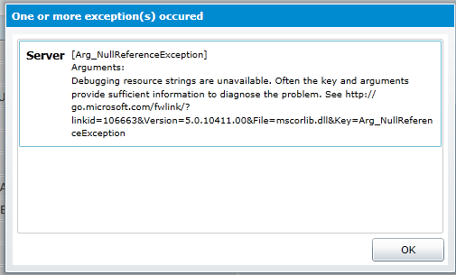
Function: “Table import” (double green arrows):
3705
We can only select a project in the perimeter and that’s all?
Can we have a view of the available list first and on the available languages too?
Which languages are imported?
The proposed perimeters are the correct ones here:
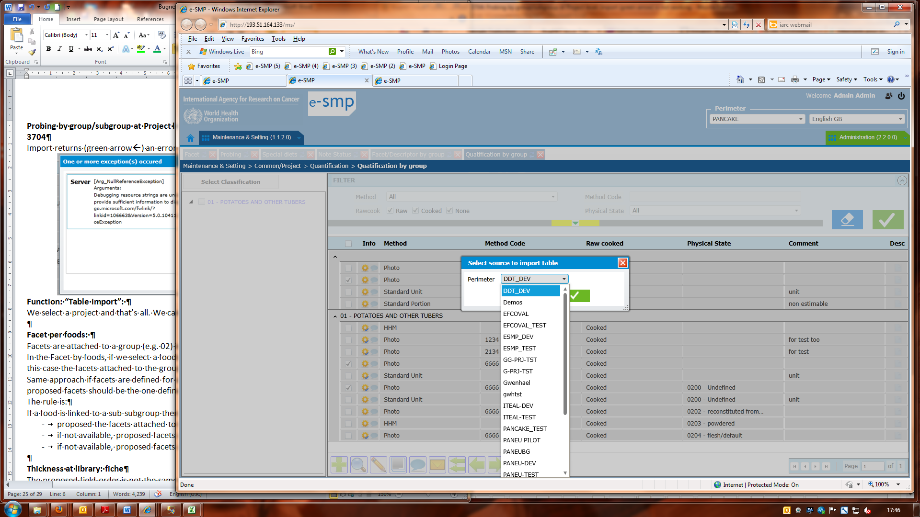

Facet per foods:
3706
Facets are attached to a group (e.g. 02) in “facets/descriptors by group” screen.
In the Facet by foods, if we select a foods attached to a subgroup (e.g. 0201), then no facet is available? In this case the facets attached to the group should be proposed (here 02).
Same approach if facets are defined for a subgroup and foods are linked to a sub-subgroup, then the proposed facets should be the one defined at subgroup level.
The rule is:
If a food is linked to a sub-subgroup then
- proposed the facets attached to this sub-subgroup
- if not available, proposed facets attached to the subgroup (of this sub-subgroup)
- if not available, proposed facets attached to the group (of this sub-subgroup)

Thickness at library: fiche presentation
3707
The proposed field order is not the same as in the list and not what we want. The order has to be:
code
comment
Thick in cm
Food classification
Recipe classification
Description
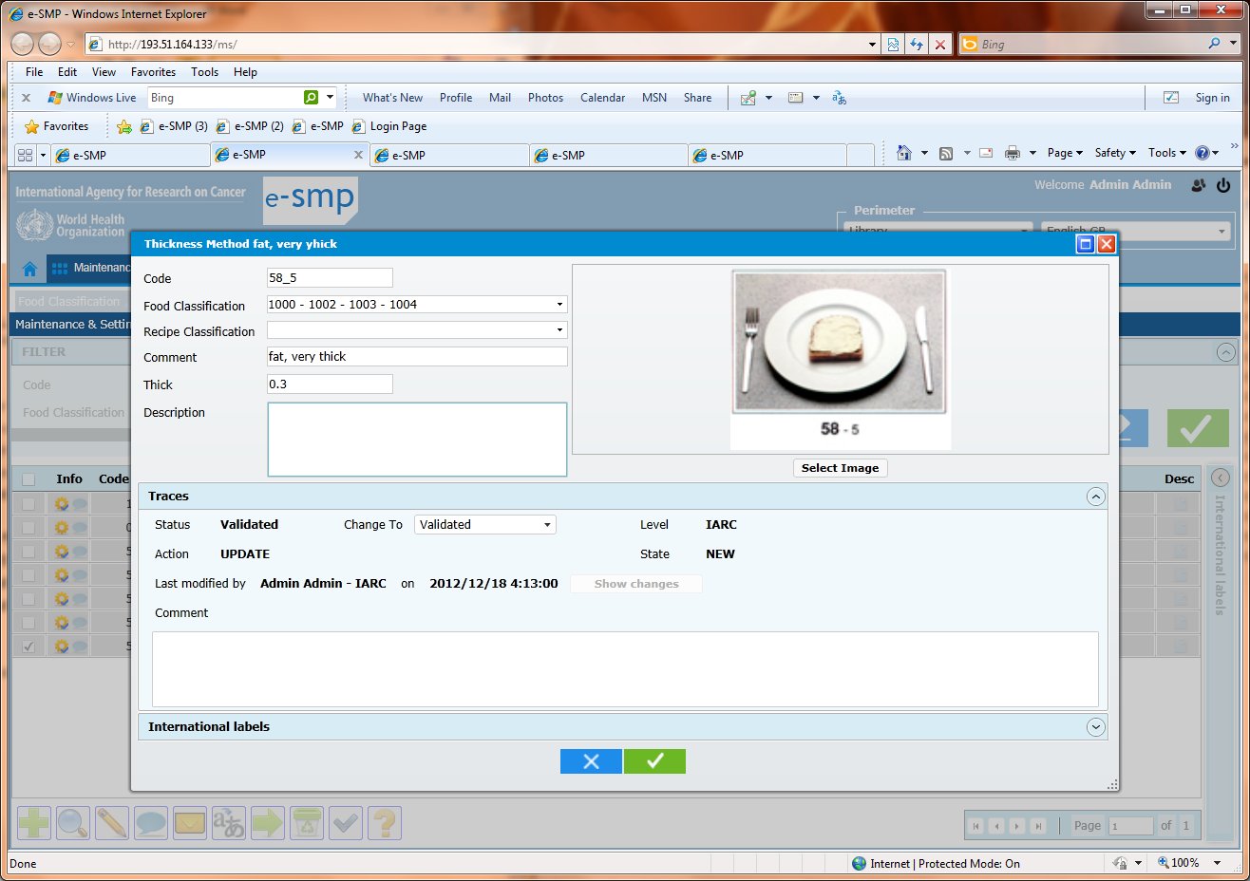
Thickness at library: list and text string
3708
No blank in the text string “food classification” (e.g. “1000,1002,1003,1004” and not “1000, 1002, 1003, 1004”)
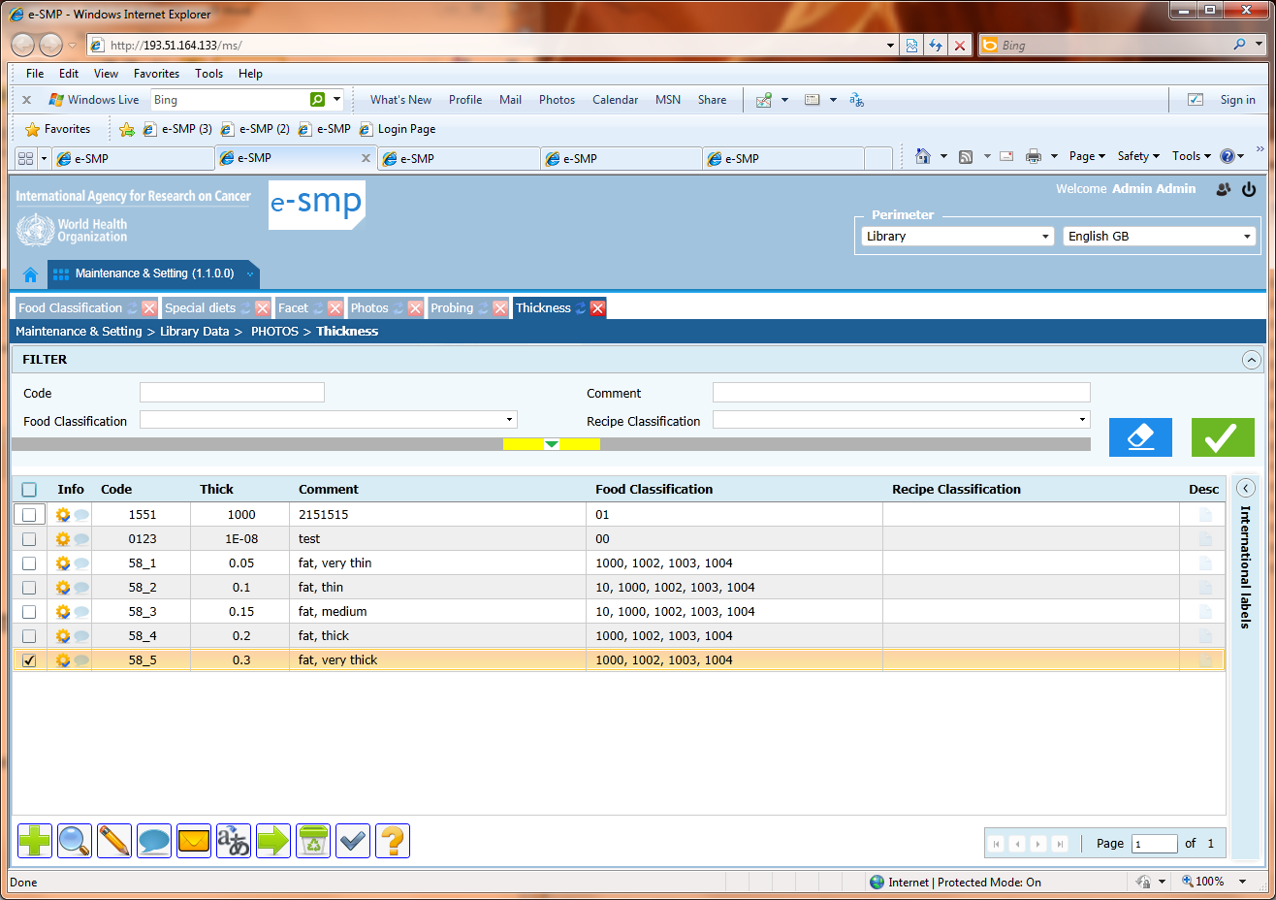

Facets/descriptors at Library level: Mass translation not possible for descriptors???
3709
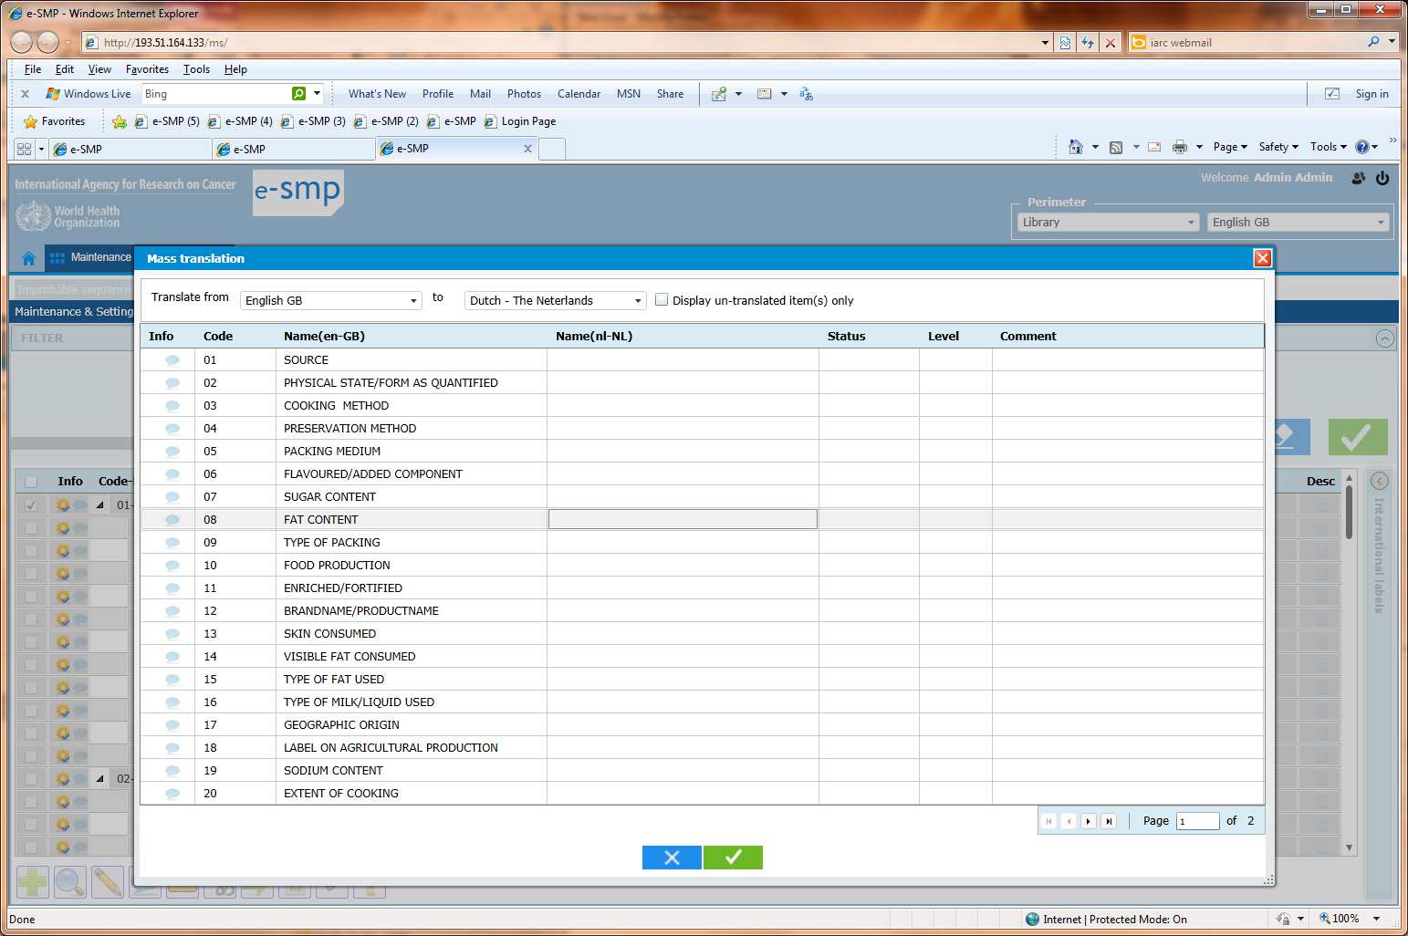

EPICTEXT: and unicity rule: we can have several times the same Epicsoft TEXT
3710
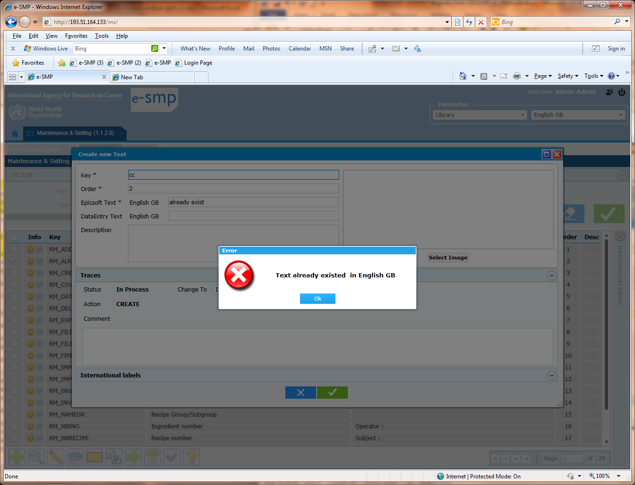

Administration & GUI translation: synchronisation between IM and SC database
3711
I add a new country and language at Administration level.
I attached this country and language to my new Project.
In library I add the translations with this new language for the table special day, special diet and note status.
At Project level I attached the different special day/diet/note status.
In administration, I export the GUI translation for this new language and I translate all.
When I import this csv-file with translation I have an error message?? If I open the table Text in SC database, all records seems to be translated.

I continue by exporting the data to synchronize with IM
Then in the database IM, table l_functional, le labels (gender, note type etc..) are not translated?

I return to Administration and export again the GUI translation. In the generated csv-file, the labels of L_functionel_label table are not translated. I update them again and import the csv-file.
After this action, the values of L_functionel_label table are translated.

To avoid the fact that we have to do twice the GUI translation (and we spend some time to understand why we cannot import the first time), it is important to add the records of L_functionel_label table in TEXT table too. Then the export to IM will also implement these records in IM. L_functionel_label table as for Special diet, day & Note status tables.

